Things in usask_server.zip & pc_pynq.zip
Part A
section | Script path | part
Server 1 | 01_baseline_light/1.1_convert_mio_to_yolo.py | S1
Server 1 | 01_baseline_light/1.3_train_yolo26n.py | S2
Server 2 | 03_profiling_error_injection/2.1_profile_yolo26n_layers.py | S3
Server 2 | 03_profiling_error_injection/2.2_profile_yolo26n_end_to_end.py | S4
Server 2 | 03_profiling_error_injection/2.3_error_injection_yolo26n.py | S5
Server 3 | 04_global_L1_shared/03_trace_mode_t4_audit.py | S6
Server 3 | 05_global_L1_p10/05_incremental_global_l1_target_search.py | S7
Server 3 | 04_global_L1_shared/stage5c_exact_core.py | S8
Server 3 | 05_global_L1_p10/08_full_20epoch_recovery.py | S9
Server 3 | 06_global_L1_p56/stage5b_exact_core.py | S10
Server 3 | 06_global_L1_p56/stage5e_exact_core.py | S11
Server 3 | 06_global_L1_p56/run_exact_gen56_pipeline.py | S12
Server 4 | 07_layer_replacement_shared/layer_replacement_adapter.py | S13
Server 4 | 07_layer_replacement_shared/03_layer_replacement_sweep_dual_domain.py | S14
Server 4 / 5 | 11_mAP50_95_measurement/05_recover_and_evaluate_selected.py | S15
Server 4 | 09_layer_replacement_p56/run_gen50_efficiency_greedy.py | S16
Server 5 | 11_mAP50_95_measurement/02_validate_supplied_baselines.py | S17
Server 5 | 12_NCNN_accuracy/evaluate_all_ncnn.py | S18
Server 5 | 12_NCNN_accuracy/run_ncnn_accuracy.sh | S19

Part B
PC/PYNQ 1 | export_baseline_ncnn.py | P1
PC/PYNQ 1 | export_pt_to_int8_ncnn.py | P2
PC/PYNQ 2 | measure_model.sh | P3
PC/PYNQ 2 | run_model.sh | P4
PC/PYNQ 3 | yolo26_ncnn_runner.cpp | P5
PC/PYNQ 4 | stream_video.py | P6
PC/PYNQ 4 | yolo26_ncnn_server.cpp | P7

Server
1. baseline-light training
2. profiling & error injection
3. baseline-full to global-L1 p10, p56
4. baseline-full to layer-replacement p10, p56
5. mAP50-95 measurment
Pynq-z2
1. ncnn size, speed measuring
2. ncnn measure runner
3. ncnn video runner from pc
Local pc
1. pt to ncnn (defaults and int8)
2. video to pynq ncnn

(not showing full codes for some part)

Part A - Server
1. Baseline-light training (Legacy)
This workflow first creates a small, reproducible MIO-TCD dataset and then trains and validates a YOLO26n baseline on it.

S1 - Convert MIO-TCD annotations to YOLO format
Script: 01_baseline_light/1.1_convert_mio_to_yolo.py
Role: Builds the 11,000-image baseline-light dataset in Ultralytics YOLO format.
Main inputs: MIO-TCD image directory, no-header annotation CSV, output folder, split counts, random seed, and copy/symlink mode.
Main outputs: YOLO image/label folders, mio_tcd.yaml, split_manifest.csv, class_balance.csv, primary_class_balance.csv, split_summary.csv, and an invalid-box audit file when needed.
- L31-L46
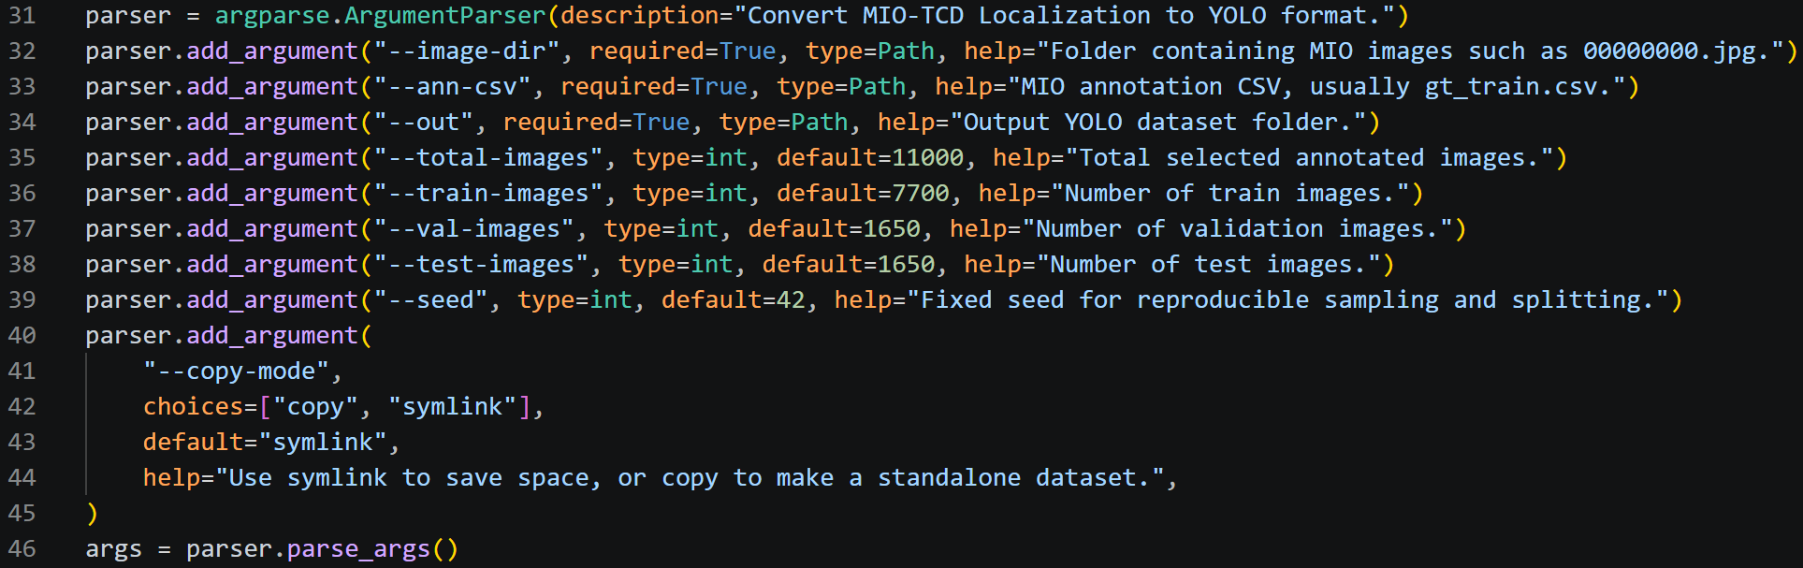
Reads the required paths and the requested 7,700/1,650/1,650 split. The default total is 11,000 images and the default seed is 42.
- L48-L63
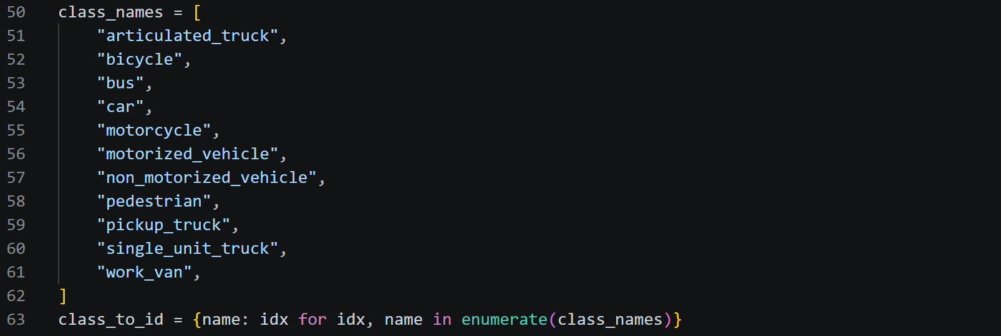
Fixes the 11 MIO-TCD class names and their YOLO class IDs. This keeps class meaning consistent across runs.
- L65-L129 - Checks the split counts, source files, class names, numeric coordinates, invalid boxes, and missing images before building the dataset.
- L131-L173
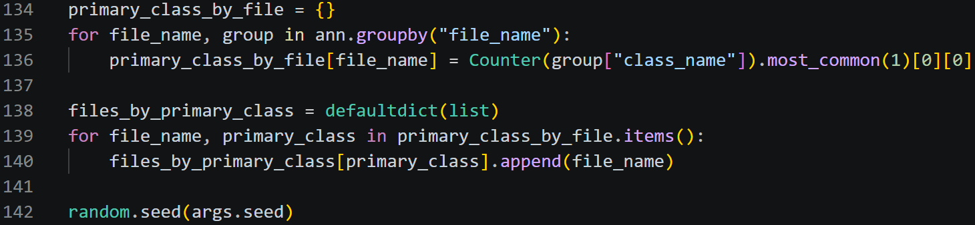
Assigns each image a primary class, shuffles with the fixed seed, and uses proportional quotas plus largest-remainder correction to select exactly 11,000 images.
- L175-L209
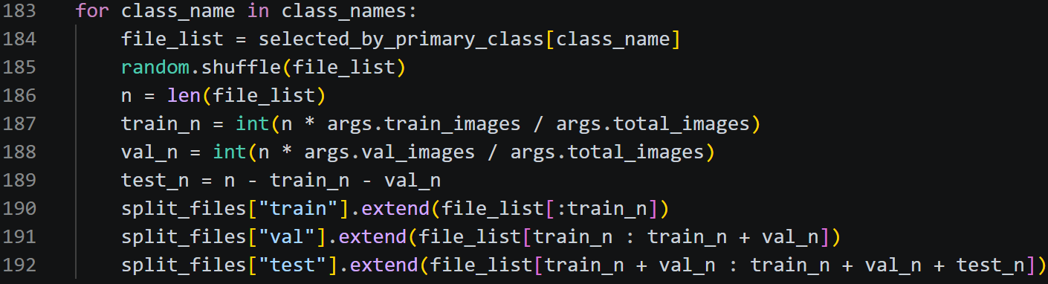
Splits the selected images by primary class, then moves files deterministically until train, validation, and test counts exactly match the requested totals.
- L211-L266 - Creates the YOLO folders, copies or symlinks each image, reads its size, converts each box from corner coordinates to normalized YOLO centre/width/height, and writes one label file per image.
- L268-L327 - Writes the dataset YAML.

S2 - Train and validate the baseline-light YOLO26n model
Script: 01_baseline_light/1.3_train_yolo26n.py
Role: Trains YOLO26n on the converted dataset and records a clean validation result.
Main inputs: A YOLO26n .pt checkpoint, dataset YAML, epochs, image size, batch size, device, workers, seed, and Ultralytics output names.
Main outputs: Ultralytics training run files, a validation run, printed mAP50-95/mAP50, and an optional test run.
- L18-L30
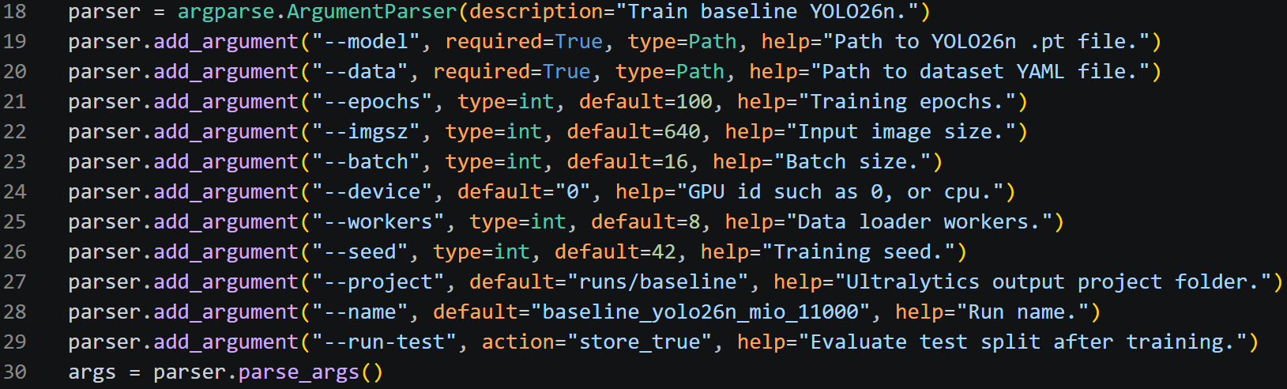
Reads all training settings. Defaults include 100 epochs, 640-pixel input, batch 16, eight workers, and seed 42.
- L32-L36 - Stops if the model checkpoint or dataset YAML does not exist.
- L38-L53
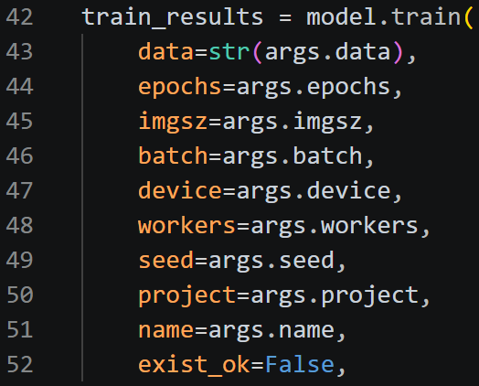
Loads the YOLO model and starts Ultralytics training with the selected train/validation splits and output folder.
- L55-L56 - Prints the training completion object.
- L58-L73
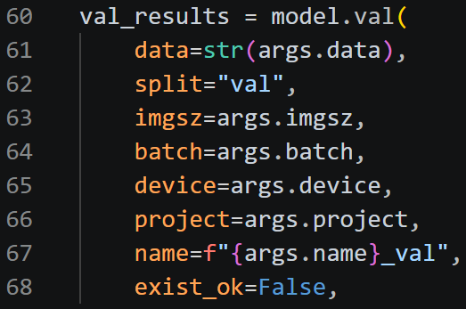
Runs a separate validation pass on split=val and prints mAP50-95 and mAP50.
- L75-L90 - Runs split=test only when --run-test is supplied.

2. Profiling and error injection (Legacy)
These scripts answer two different questions: where compute time is spent, and which layer outputs are sensitive to numerical disturbance.

S3 - Measure layer-by-layer compute latency
Script: 03_profiling_error_injection/2.1_profile_yolo26n_layers.py
Role: Times each top-level YOLO layer using a manual forward pass through the Ultralytics graph.
Main inputs: A .pt model, input size, CPU/GPU device, warm-up count, measured iteration count, seed, and output CSV.
Main outputs: A CSV containing layer ID, type, source connection, parameter count, mean latency, latency share, and output shape.
- L20-L38
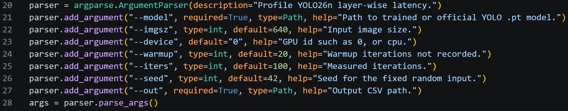
Reads profiling settings and checks that a requested CUDA device is available.
- L40-L48
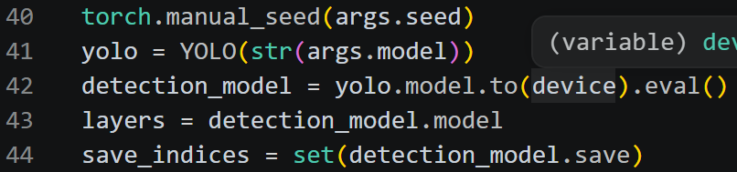
Sets the seed, loads the model in evaluation mode, and creates one fixed random input tensor.
- L53-L59
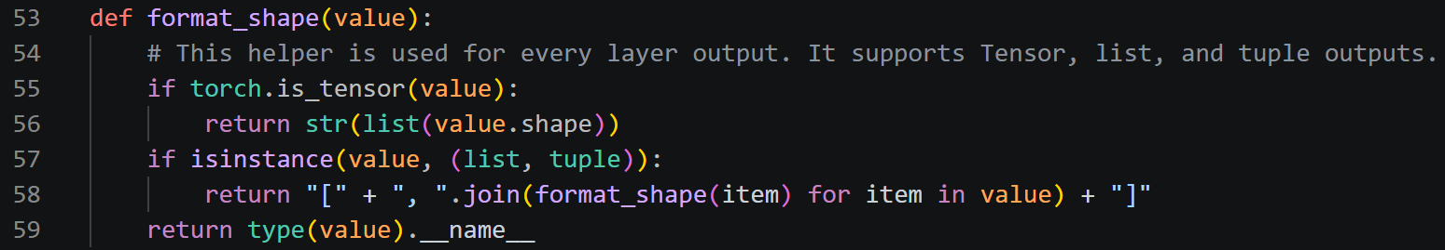
Formats tensor, list, and tuple output shapes for the report.
- L62-L95
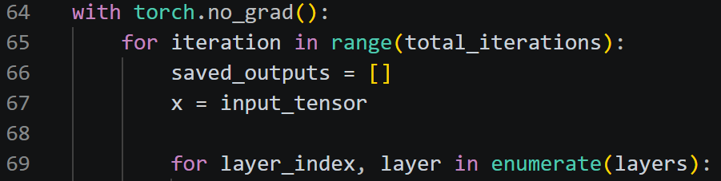
Runs the YOLO graph manually. It follows each layer.f connection, synchronizes CUDA before and after timing, excludes warm-up iterations, and keeps only graph outputs required later.
- L96-L113
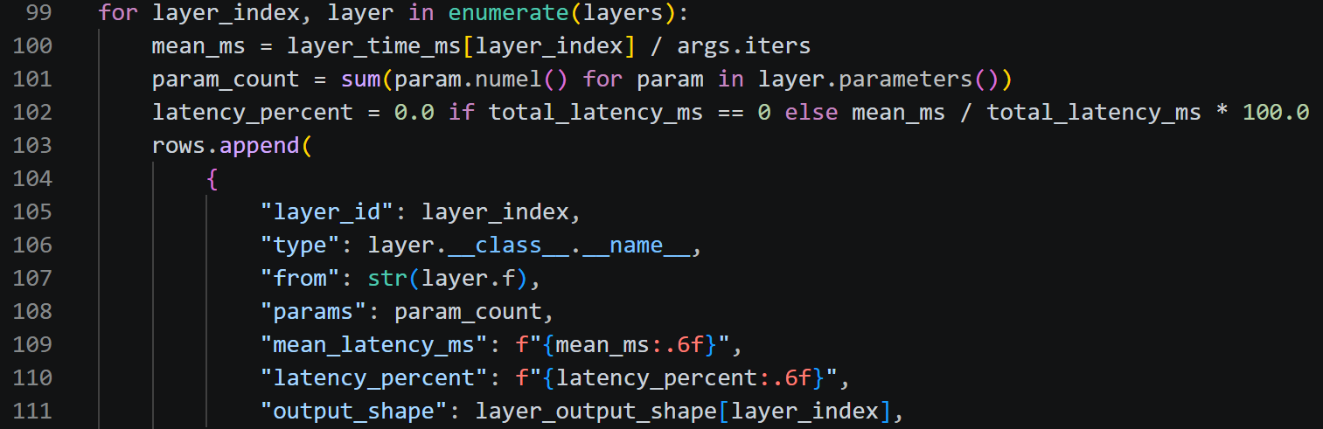
Calculates each layer mean time, parameter count, percentage of the summed layer time, and recorded output shape.

S4 - Measure end-to-end validation speed and resources
Script: 03_profiling_error_injection/2.2_profile_yolo26n_end_to_end.py
Role: Runs Ultralytics validation and records accuracy, preprocessing/inference/postprocessing time, CPU use, memory, and FPS.
Main inputs: A .pt model, dataset YAML, split, image size, batch, device, workers, Ultralytics output names, and output CSV.
Main outputs: One CSV row with mAP, latency components, FPS, elapsed time, process CPU percentage, RSS values, and optional CUDA peak memory.
- L31-L42
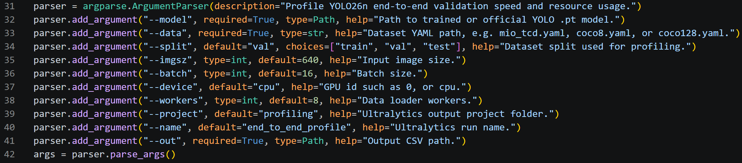
Reads the model, dataset, split, image size, batch, device, worker count, and output settings.
- L44-L60 - Checks the model and dataset argument, creates a process monitor, loads YOLO, and resets CUDA peak-memory statistics when a GPU is used.
- L62-L98
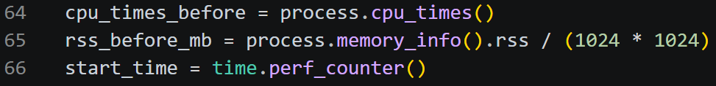
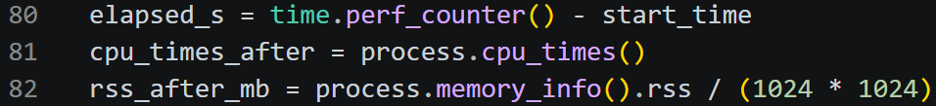
Records process CPU time and RSS before validation, runs model.val(), then records wall time, CPU time, RSS after validation, and peak allocated CUDA memory.
- L99-L106
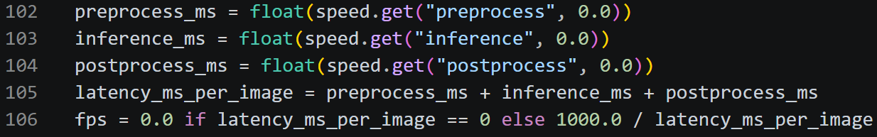
Reads Ultralytics per-image preprocess, inference, and postprocess times, adds them, and converts total milliseconds per image to FPS.
- L108-L158 - Writes accuracy, speed, CPU, RSS, and GPU-memory values to one CSV row.

S5 - Inject activation noise one layer at a time
Script: 03_profiling_error_injection/2.3_error_injection_yolo26n.py
Role: Measures layer sensitivity by adding Gaussian noise to one layer output and observing the mAP drop.
Main inputs: A .pt model, dataset YAML, validation/test split, optional layer list, noise ratio, image size, batch, device, workers, seed, and output CSV.
Main outputs: A progress CSV with the baseline and one row per injected layer, including mAP and accuracy drops.

- L23-L36
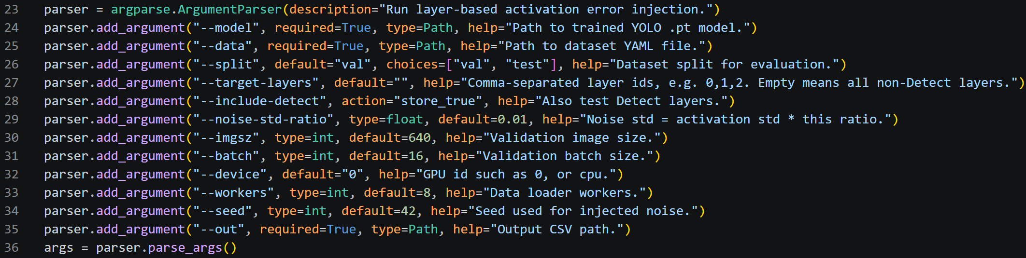
Reads the model, dataset, target layers, Detect-layer policy, noise strength, evaluation settings, seed, and output path.
- L38-L60 - Checks inputs and builds the target-layer list. Detect is excluded unless --include-detect is passed.
- L62-L100
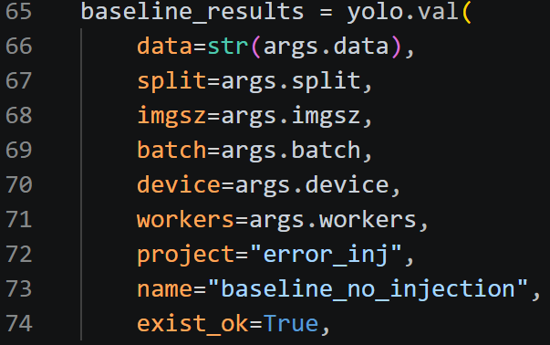
Runs an unmodified baseline validation first and writes the baseline row to the CSV.
- L101-L123
Creates a forward hook for the selected layer. The noise seed is seed + layer_id, and noise standard deviation is activation standard deviation multiplied by the requested ratio.
- L124-L138
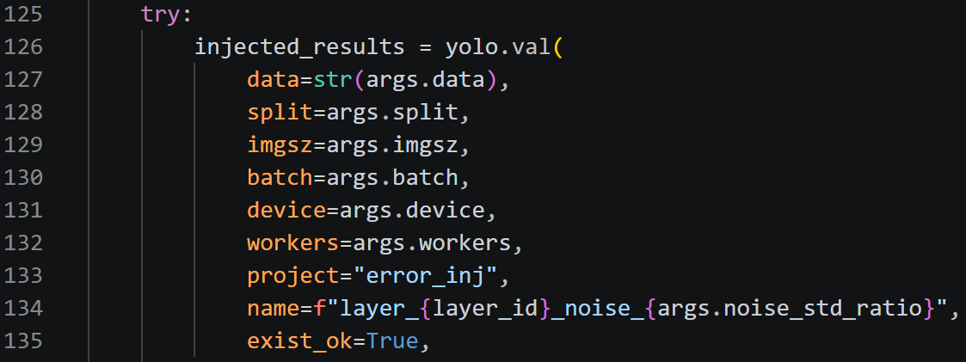
Attaches the hook, runs validation, and always removes the hook after that one layer test.
- L140-L155
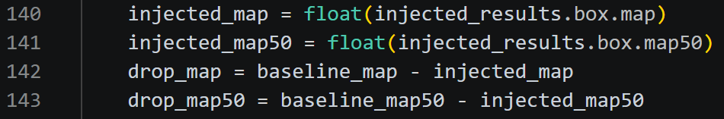
Calculates signed mAP50-95 and mAP50 drops relative to the baseline.

3. Baseline-full to Global-L1 p10 and p56
The Global-L1 workflow is split into auditable stages: confirm dependency-safe scope, search a channel-removal plan, replay that plan into a raw checkpoint, and recover the exact pruned architecture.

S6 - Audit dependency-graph trace modes and the 42-root pruning scope
Script: 04_global_L1_shared/03_trace_mode_t4_audit.py
Role: Checks which Torch-Pruning trace mode exposes the required Global-L1 roots without changing the models.
Main inputs: GEN and SNOW baseline checkpoints, T4 group table, validated-group manifest, protected-root manifest, output folder, image size, and device.
Main outputs: Per-trace-mode root audits, selected-root dependency details, global L1 channel ranking, environment data, and a pass/fail summary.
- L108-L145
Configures a model for each trace mode and builds a Torch-Pruning DependencyGraph while keeping autograd available.
- L148-L227
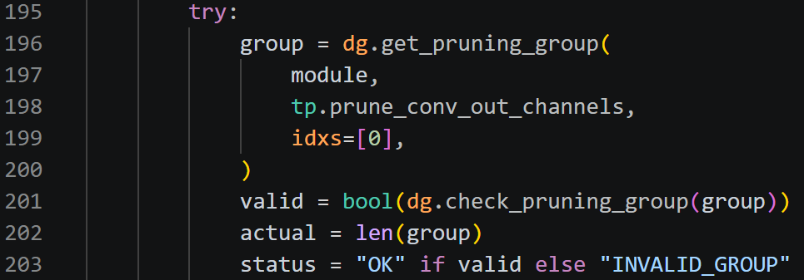
Probes every generic root and records whether a valid dependency group can be formed.
- L230-L321
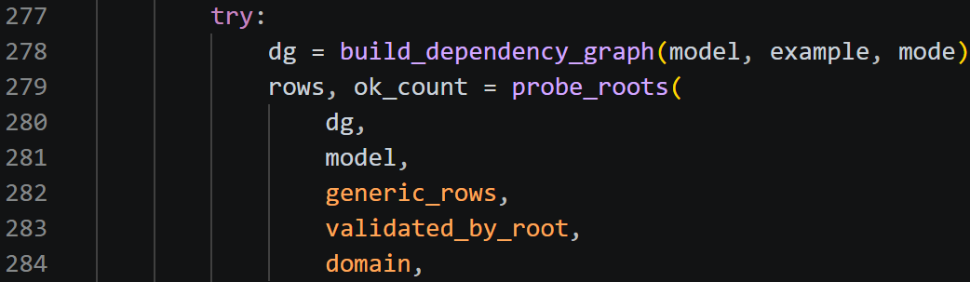
Runs all trace modes for one domain, compares their coverage, and selects the mode that exposes the most authoritative roots.
- L323-L452
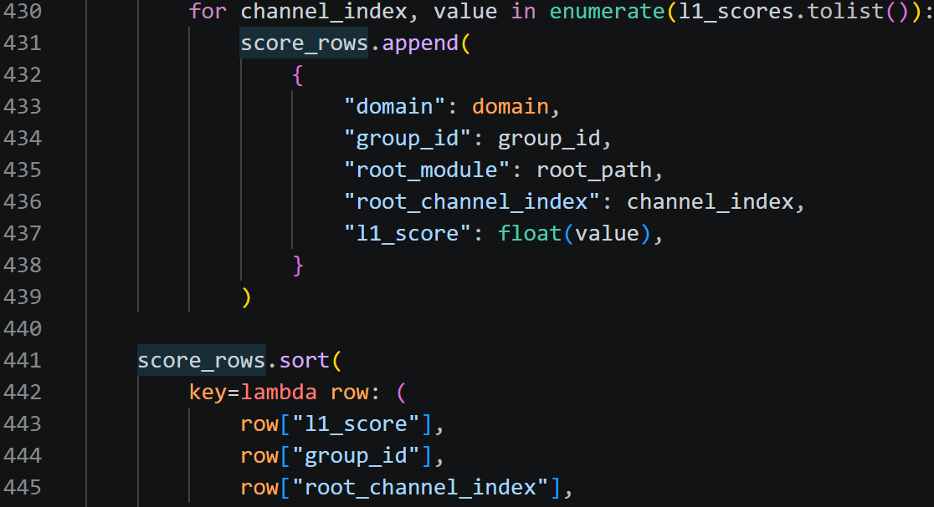
Rebuilds the selected graph, audits dependency operations, and ranks every output channel by its L1 filter magnitude.
- L477-L622
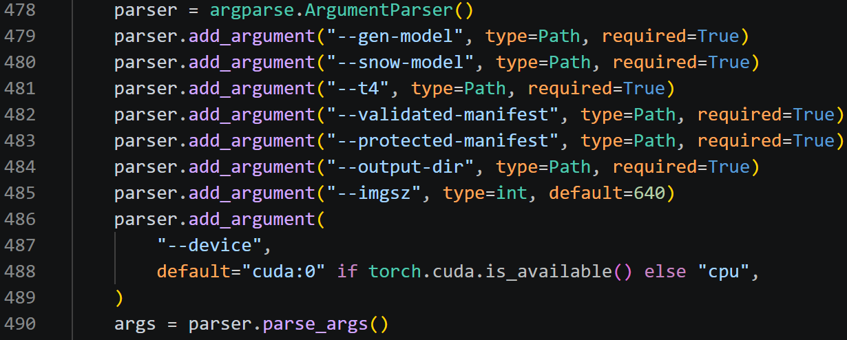
Loads GEN/SNOW inputs, separates generic/custom/protected scope, runs both audits, checks for 42 valid roots and 3,528 channel scores.

S7 - Search the p10 Global-L1 pruning plan
Script: 05_global_L1_p10/05_incremental_global_l1_target_search.py
Role: Finds a deterministic dependency-safe sequence of low-L1 channel removals near the requested p10 parameter target.
Main inputs: GEN/SNOW baseline checkpoints, T4 table, protected manifest, target parameters, image size, seed, per-root pruning limit, minimum channels, and output folder.
Main outputs: Incremental search logs, rejected-candidate logs, before/after root inventories, chosen_replay_plan.csv, protocol/environment JSON, and summaries.
- L129-L174
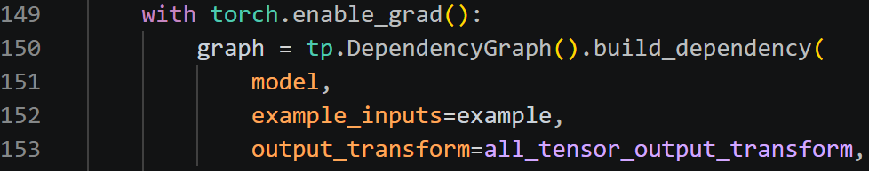
Builds the DependencyGraph and normalizes dependency-group channel indices.
- L177-L243 - Rejects any candidate that would prune a protected output, violate minimum remaining channels, or fail dependency-group validation.
- L246-L316
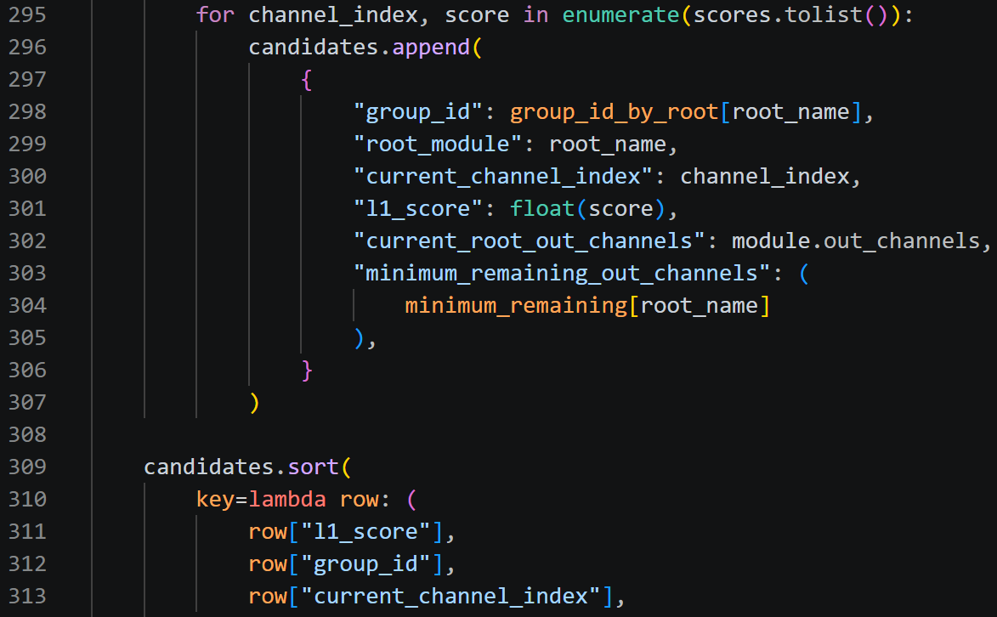
Builds the current root inventory and globally sorts every eligible channel by its current L1 magnitude.
- L356-L528
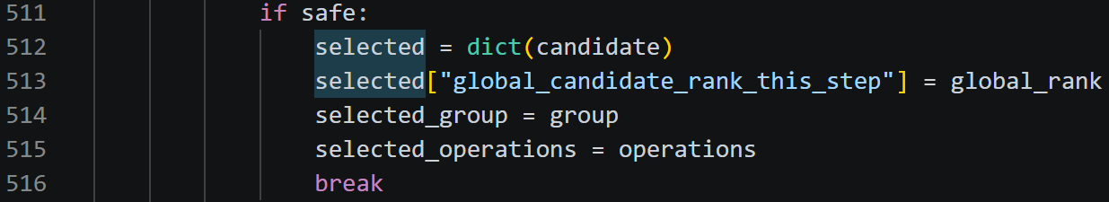
Loads a fresh baseline, verifies scope, repeatedly rebuilds the graph, and finds the smallest-L1 candidate that passes all safety checks.
- L530-L648
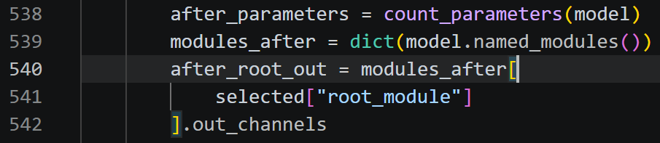
Physically applies each accepted dependency group to the in-memory search model, checks forward execution and protected outputs, and records every step.
- L650-L774 - Stops after crossing the target, chooses the closer plan from immediately before or after the crossing, writes chosen_replay_plan.csv, and reports the final root inventory.
- L777-L986 - Runs the same procedure for GEN and SNOW.

S8 - Replay an approved Global-L1 plan and create raw checkpoints
Script: 04_global_L1_shared/stage5c_exact_core.py
Role: Replays chosen channel removals on fresh baselines, saves structurally pruned raw .pt files, reloads them, and validates them.
Main inputs: GEN/SNOW baselines, dataset YAML files, Stage-5B search directory/plans, T4 table, protected manifest, output folder, and fixed validation settings.
Main outputs: Raw pruned checkpoints, replay progress, architecture hashes/inventories, protected-output verification, raw validation metrics, and Stage-5C summaries.
- L130-L172
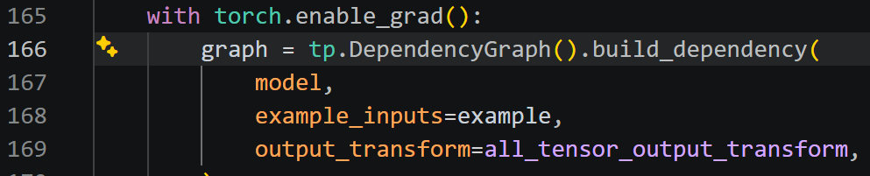
Sets deterministic behaviour and rebuilds the same DependencyGraph trace used by the search.
- L265-L358 - Reads the replay plan, loads a fresh baseline, captures protected outputs, and records the original architecture.
- L359-L553
Replays every plan row in order. Before each prune it checks the expected root, channels, parameters, and L1 value; it then applies the dependency group and records progress.
- L555-L635
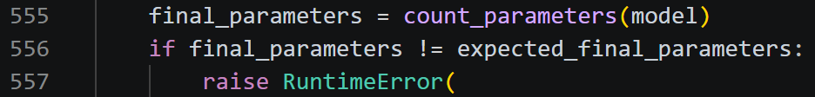
Checks the final parameter count, protected outputs, 42-root inventory, architecture hash, and saves the raw checkpoint.
- L637-L684 - Reloads the saved checkpoint and proves that parameter count, architecture hash, and a forward pass survive serialization.
- L690-L795
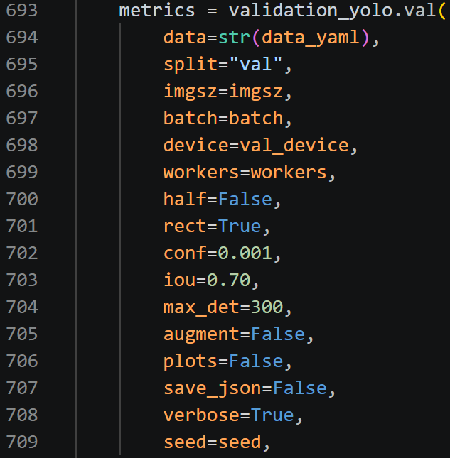
Runs fixed FP32 validation and records raw mAP, signed drop, and accuracy retention against the frozen baseline.
- L798-L1060 - Runs GEN and SNOW.

S9 - Recover a p10 Global-L1 raw model for 20 epochs
Script: 05_global_L1_p10/08_full_20epoch_recovery.py
Role: Fine-tunes one exact physically pruned model for 20 continuous epochs and verifies that its structure does not change.
Main inputs: Domain, raw .pt model, dataset YAML, output folder, image size, batch, workers, epochs, seed, and device.
Main outputs: Recovery run, best/last recovered checkpoints, results.csv, protocol, checkpoint audits, final validation metrics, and a domain summary.
- L60-L85 - Stores expected p10 parameter counts, frozen baseline metrics, and raw metrics used for the final comparison.
- L199-L218
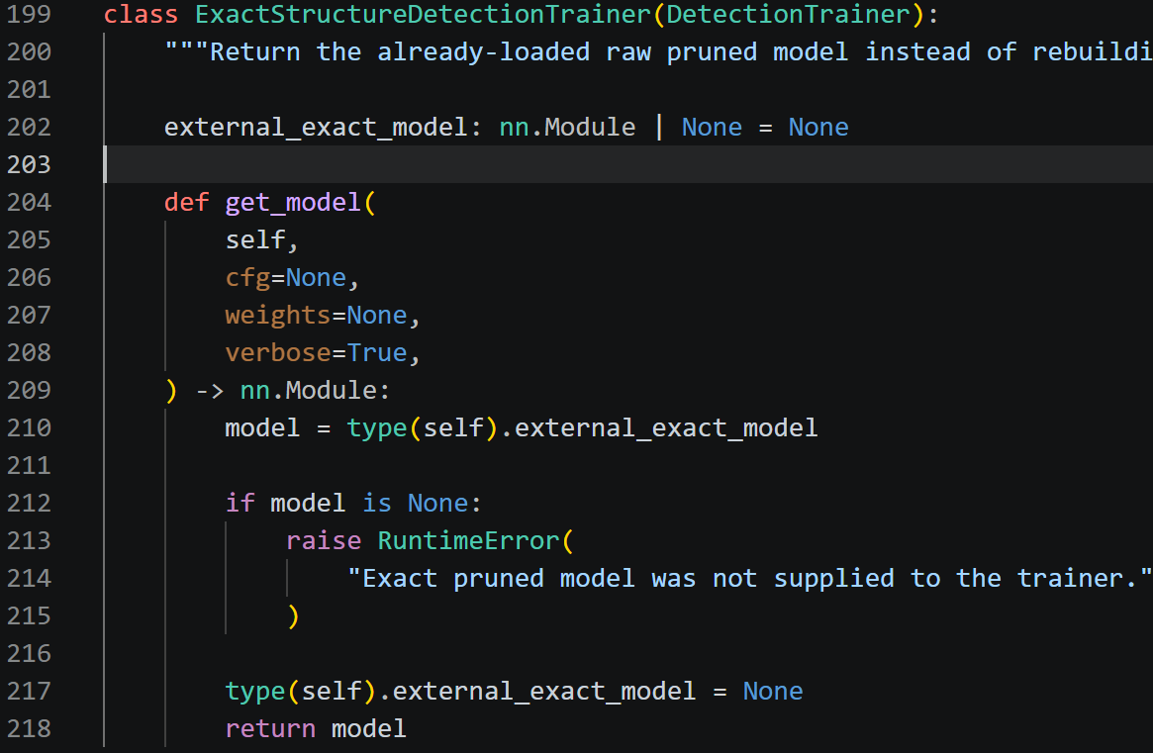
Defines a custom DetectionTrainer that returns the already-pruned model object instead of constructing a new unpruned network from YAML.
- L221-L341 - Parses the training CSV and inspects checkpoints for expected epoch count, finite values, parameter count, architecture hash, and finite forward output.
- L359-L418
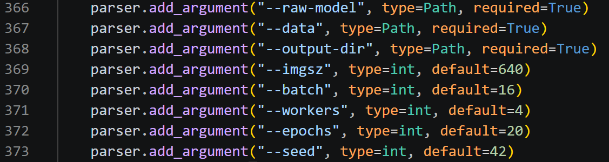
Reads arguments, checks files, requires exactly 20 epochs, and verifies the source raw model parameters.
- L425-L507
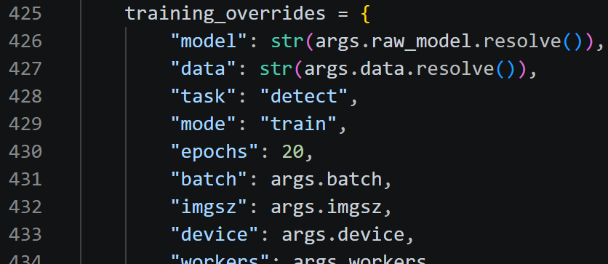
Builds fixed AdamW training/validation settings, injects the raw model into the custom trainer, and starts training.
- L509-L569 - Checks best.pt, last.pt, and results.csv, verifies architecture/parameters, and copies the recovered checkpoints to stable names.
- L571-L603
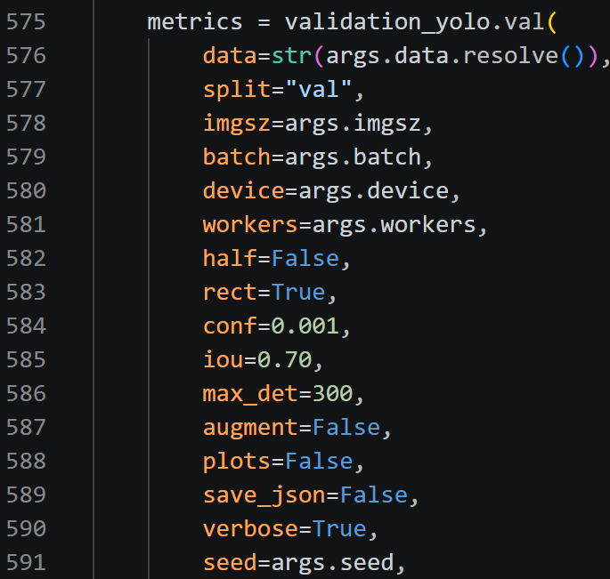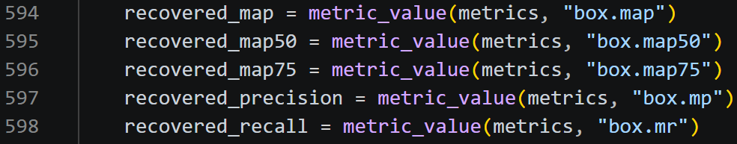
Runs a separate fixed final validation on the recovered best checkpoint.
- L608-L741 - Evaluates all pass/fail conditions.

S10 - Reusable Stage-5B core used by the p56 pipeline
Script: 06_global_L1_p56/stage5b_exact_core.py
Role: Provides the same incremental Global-L1 search engine as the p10 search, packaged as an importable module.
Main inputs: Baseline checkpoints, T4/protected scope, target parameter values, and search settings supplied either by its CLI or by run_exact_gen56_pipeline.py.
Main outputs: The same plan/search CSV and JSON evidence as the p10 search.
- L131-L176
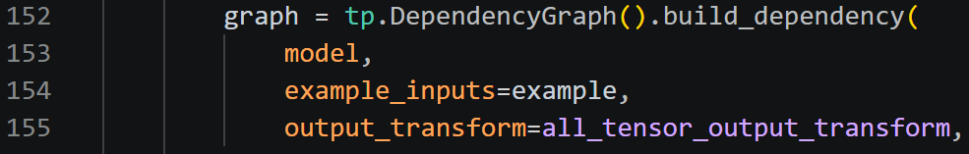
Builds the dependency graph and normalizes channel indices.
- L179-L245
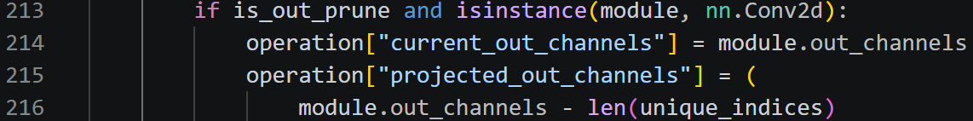
Applies protected-root, minimum-channel, and dependency-group safety checks.
- L248-L318
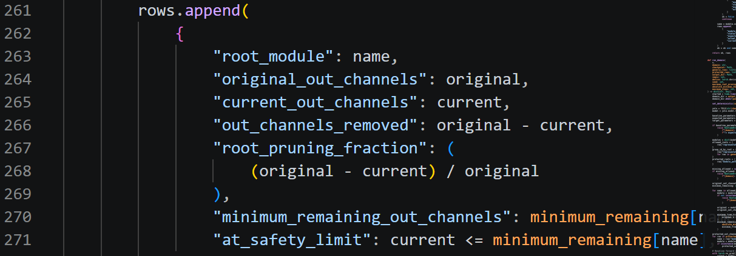
Builds root inventories and a global list of current channel L1 candidates.
- L358-L776
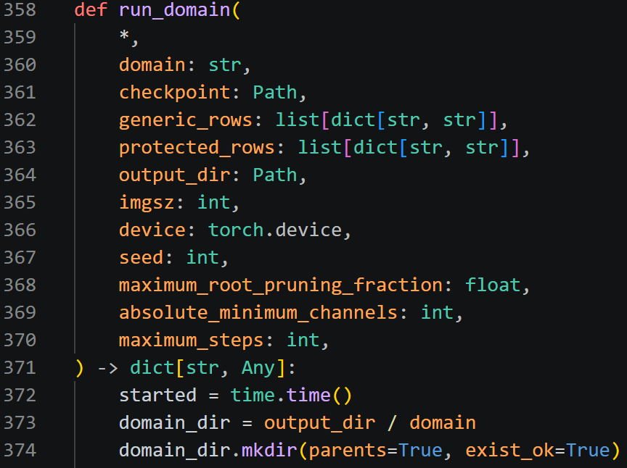
Runs the deterministic search, applies one accepted prune at a time, rebuilds the graph, logs rejections/progress, and selects the closest target-crossing plan.

S11 - Reusable Stage-5E recovery core used by the p56 pipeline
Script: 06_global_L1_p56/stage5e_exact_core.py
Role: Provides the same exact-architecture 20-epoch recovery procedure as the p10 recovery script.
Main inputs: A raw model, dataset, expected parameter count, frozen baseline/raw metrics, and recovery settings supplied by CLI or temporarily set by the p56 orchestrator.
Main outputs: Recovered best/last checkpoints, training CSV, protocol, audits, final validation metrics, and summary.
- L199-L218
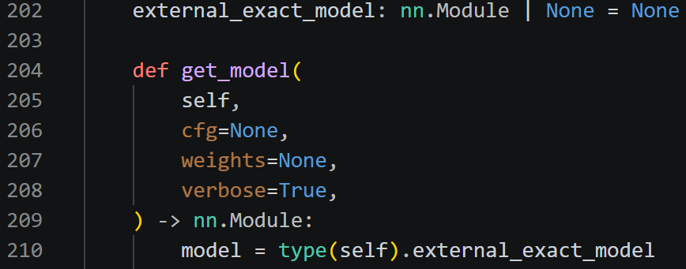
Uses the custom exact-structure DetectionTrainer so the supplied pruned model is preserved.
- L221-L341 - Checks training rows, finite values, parameters, architecture, and forward output.
- L359-L418
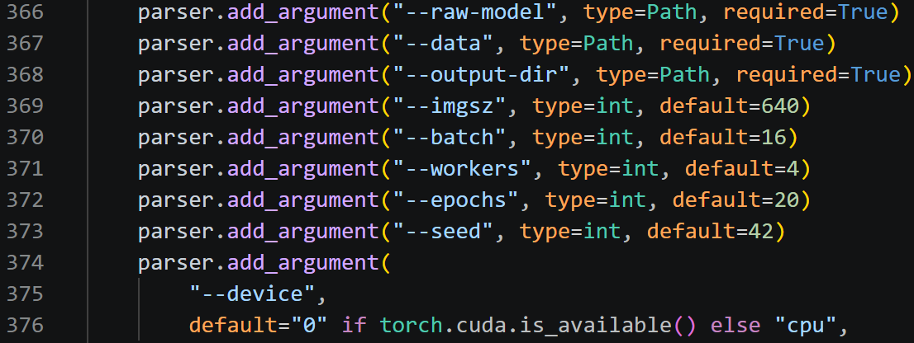
Reads/validates arguments and confirms the raw checkpoint matches the expected structure.
- L425-L569
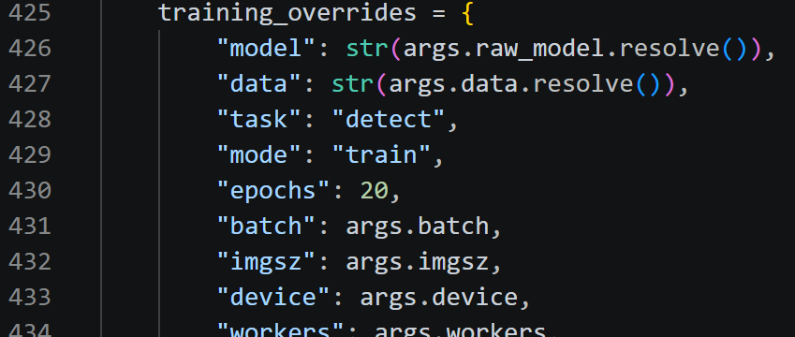
Runs the fixed 20-epoch training, verifies best/last/results, and copies stable recovered checkpoint names.
- L571-L741
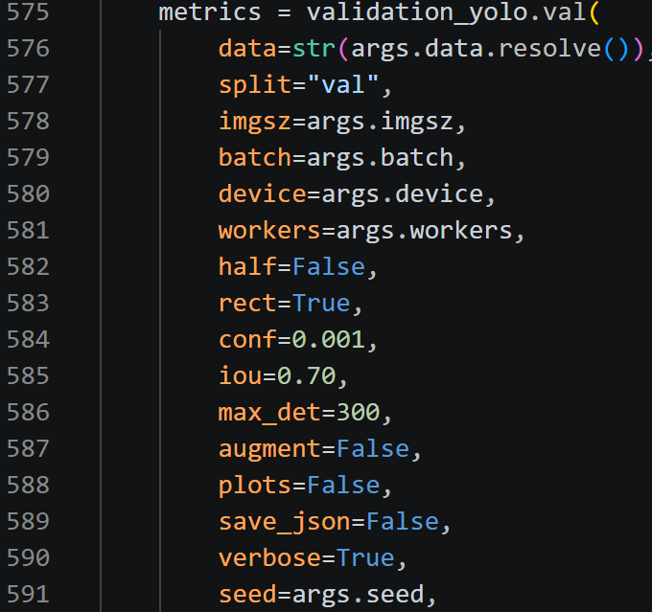
Runs final validation and writes the pass/fail summary and comparison table.

S12 - Run the complete GEN p56 Global-L1 pipeline
Script: 06_global_L1_p56/run_exact_gen56_pipeline.py
Role: Orchestrates p56 search, raw-plan replay, 20-epoch recovery, validation, reporting, and bundling for GEN.
Main inputs: GEN baseline/data, T4 table, protected manifest, output folder, target reduction, image size, batch, workers, seed, and device.
Main outputs: Selected search plan, raw p56 checkpoint, recovered best/last checkpoints, metrics/report tables, summaries, README, and a ZIP bundle.
- L83-L94
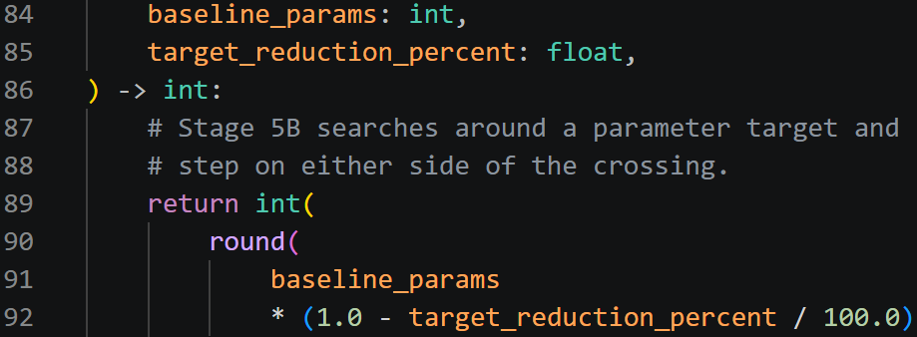
Converts the requested reduction percentage to a target remaining-parameter count.
- L104-L157
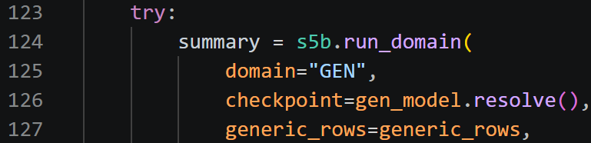
Runs one search attempt by temporarily setting the Stage-5B GEN target, then records the cap and target used.
- L160-L219
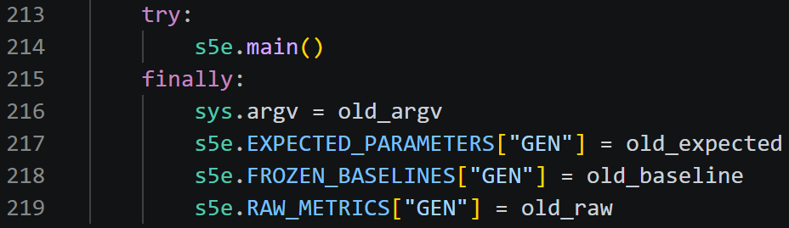
Temporarily supplies the real p56 expected parameters and raw/baseline metrics to the Stage-5E module and invokes its CLI main function.
- L222-L355 – (parser) Reads inputs, checks paths, separates the T4 table into 42 generic and 9 custom groups, and writes the protocol.
- L361-L420
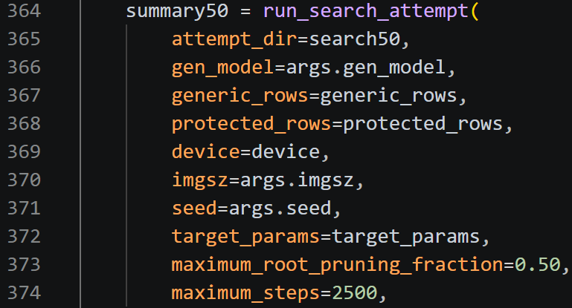
First searches with a 50% per-root cap. If that fresh run cannot reach the target, it restarts from the untouched baseline with a 90% cap while keeping at least four channels.
- L422-L516
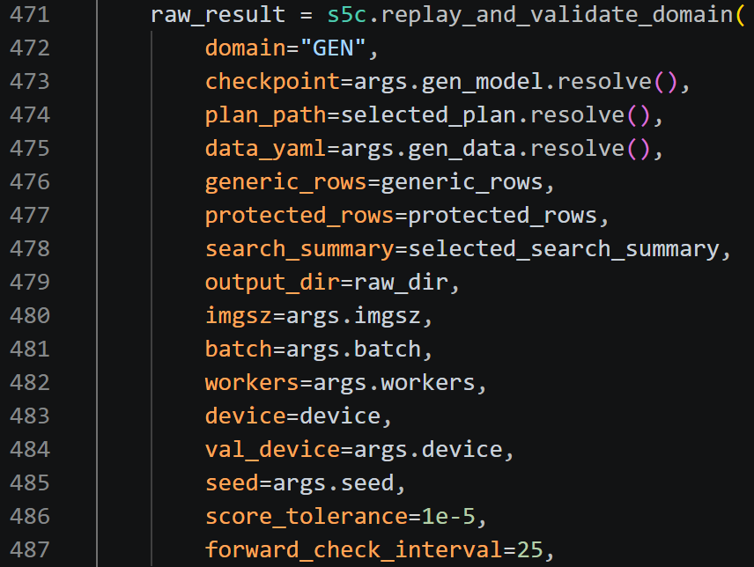
Copies the selected replay plan, calls Stage 5C, verifies the raw checkpoint, and copies it to the p56 output name.
- L518-L585
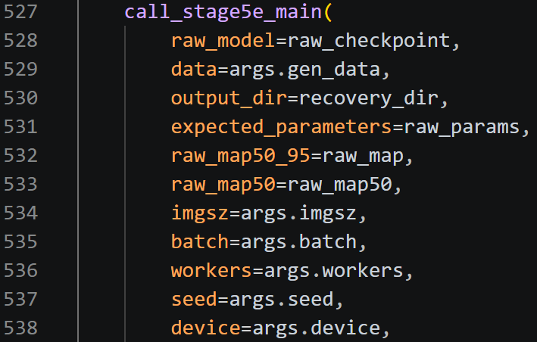
Calls exact 20-epoch recovery, verifies the passing recovery summary, and copies the final best/last checkpoints.

4. Baseline-full to layer replacement p10 and p56
Layer replacement removes an entire learned layer and inserts a parameter-free adapter that preserves the expected tensor interface. The scripts first test single layers, then recover selected p10 candidates or build a multi-layer p56 model.

S13 - Parameter-free dynamic layer adapter
Script: 07_layer_replacement_shared/layer_replacement_adapter.py
Role: Defines the replacement module used when an original YOLO layer is physically removed.
Main inputs: One tensor or a nested list/tuple of 4D NCHW tensors, plus stored target channel/spatial ratios and a multi-input policy.
Main outputs: One 4D tensor with the target spatial dimensions and target channel count.
- L20-L48
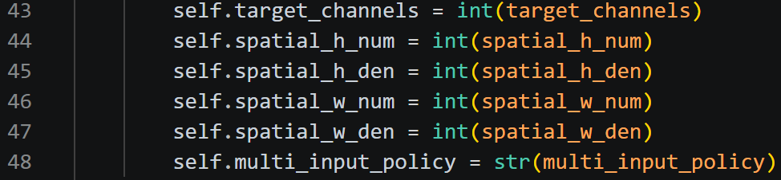
Stores the target channel count, rational spatial scaling ratios, and either concat or first-input policy.
- L50-L59
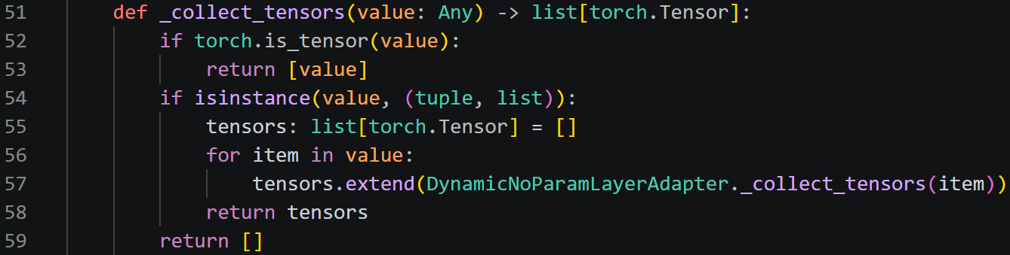
Recursively collects tensors from tensor/list/tuple inputs.
- L61-L71
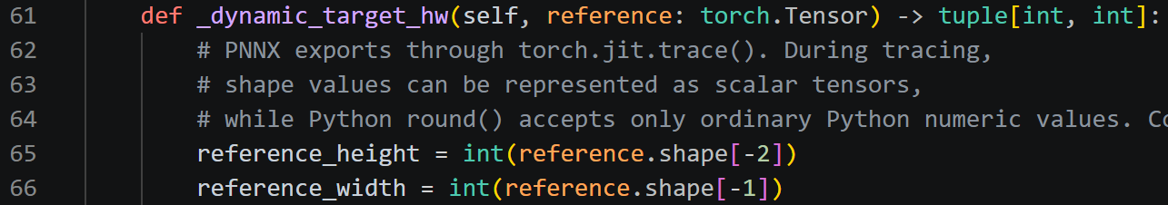
Computes the target height and width dynamically from the first input tensor and the stored ratios.
- L73-L77
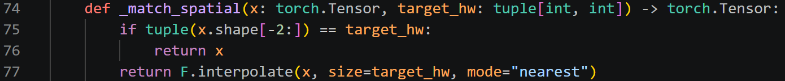
Uses nearest-neighbour interpolation only when spatial size must change.
- L79-L88
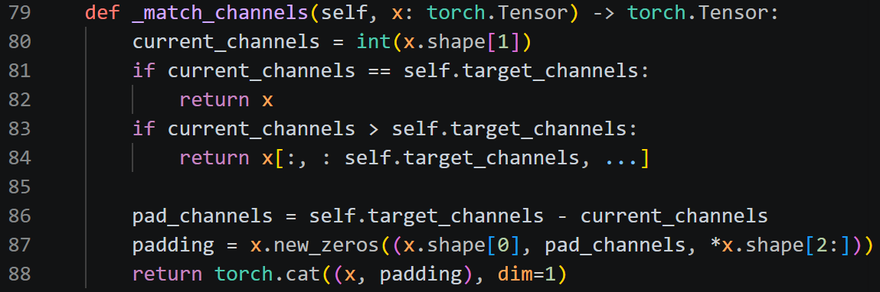
Crops excess channels or appends zero-filled channels until the required channel count is reached.
- L90-L105
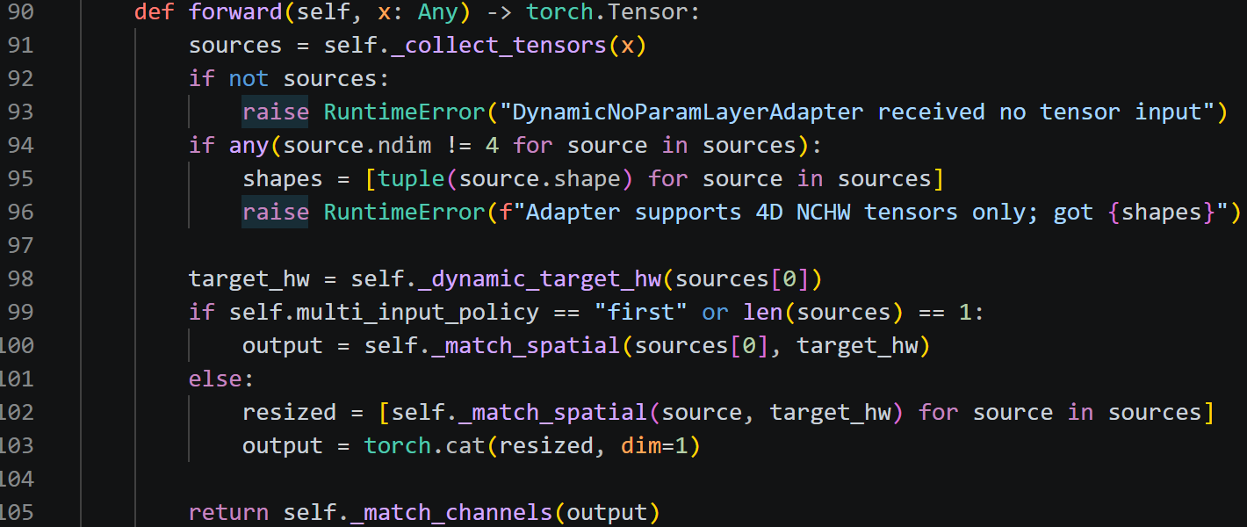
Selects the first input or concatenates resized inputs, then applies channel matching.
- L116-L120
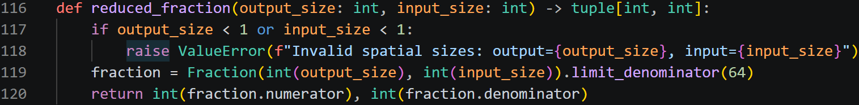
Reduces a measured output/input spatial ratio to a small integer fraction for storage in the adapter.

S14 - Sweep one replaced layer across GEN and SNOW
Script: 07_layer_replacement_shared/03_layer_replacement_sweep_dual_domain.py
Role: Tests each eligible layer individually, saves raw replacement checkpoints, and ranks layers by parameter reduction and accuracy impact.
Main inputs: GEN/SNOW baselines and datasets, Stage-1 baseline CSV, target-layer selection, validation settings, adapter policy, output folder, and device.
Main outputs: Raw one-layer replacement .pt files, raw result CSV, GEN/SNOW sensitivity rankings, dual-domain score ranking, metadata, hashes, environment, and summary.
- L80-L113
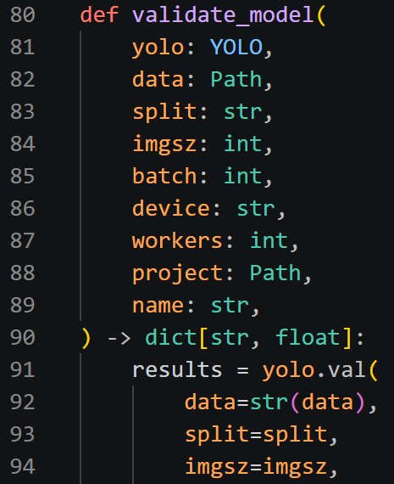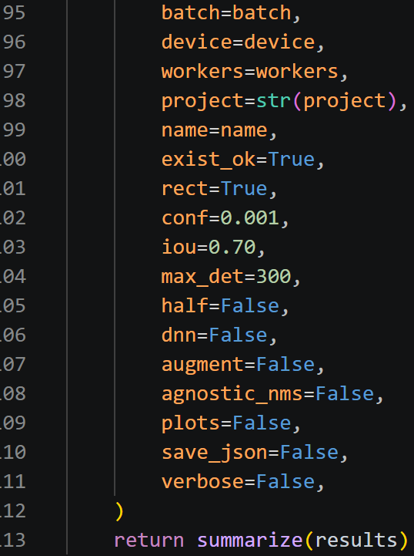
Defines one fixed FP32 validation routine and extracts mAP, precision, recall, latency, and FPS.
- L143-L183
Attaches a temporary hook to the original layer and captures its input/output tensor shapes, channel count, and spatial ratio.
- L186-L220
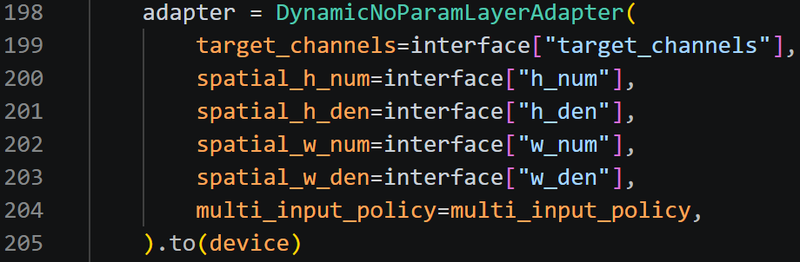
Builds the adapter, copies Ultralytics graph metadata such as f and i, and replaces the selected layer in the model list.
- L272-L361
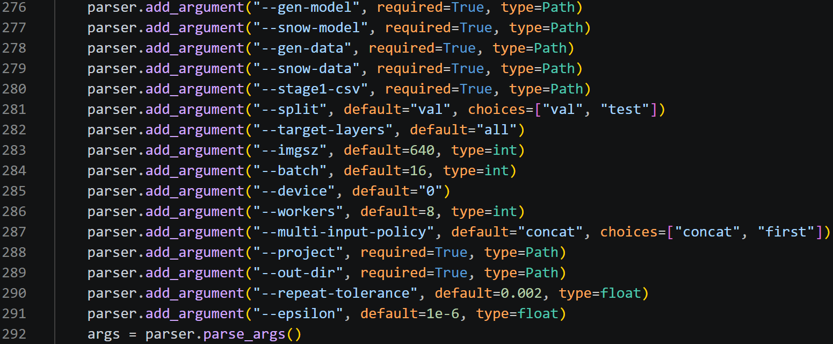
Reads arguments, records environment/checksums, loads GEN/SNOW baselines, verifies class counts and matching top-level model structure, and repeats the baseline validation gate.
- L421-L472
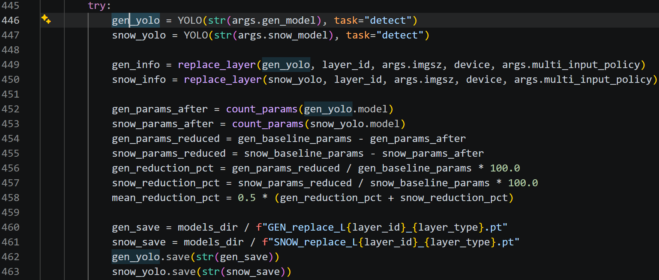
For each parameterized non-skipped layer, loads fresh GEN/SNOW models, replaces the same layer, calculates parameter reduction, saves both raw checkpoints, and verifies they reload correctly.
- L474-L483
Validates the two replaced models.
- L485-L536
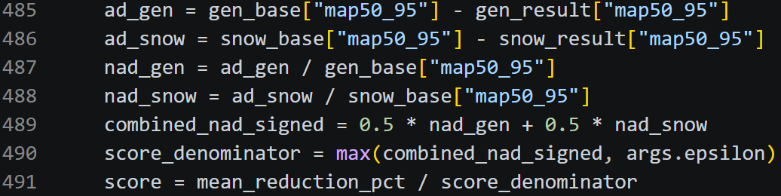
Calculates signed accuracy drop (AD), normalized drop (NAD), mean parameter reduction, and a dual-domain score using reduction divided by the signed combined NAD with an epsilon floor.
- L538-L548
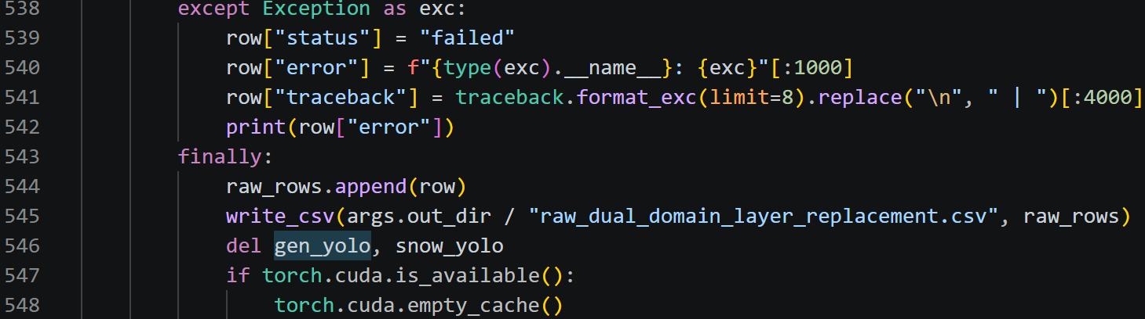
Records failures.
- L550-L594
Writes three rankings: GEN accuracy sensitivity, SNOW sensitivity, and dual-domain physical-layer score.

S15 - Recover and evaluate the selected p10 layer-replacement candidates
Script: 11_mAP50_95_measurement/05_recover_and_evaluate_selected.py
Role: Preserves the selected adapter architectures, performs smoke or full recovery training, and compares baseline, raw, and recovered mAP.
Main inputs: Stage-1 baseline CSV, Stage-2 one-layer CSV, Stage-3 combination CSV, GEN/SNOW baselines and datasets, output folder, device/workers, and smoke/full mode.
Main outputs: Source inventory/checksums, architecture audits, recovery runs, best/last checkpoints, progress CSV, baseline/raw/recovered comparison CSV, environment/settings, and summary.
- L87-L131
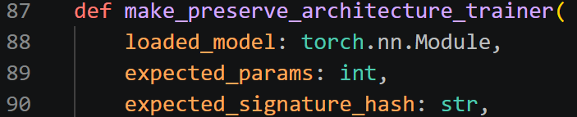
Builds a custom trainer that injects the already-loaded adapter model and checks parameter count and architecture signature.
- L167-L196
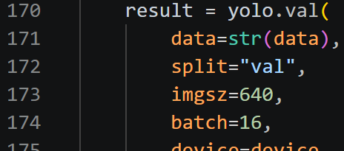
Defines the fixed FP32 validation used for recovered models.
- L199-L269 - Defines one-epoch smoke settings or the full 20-epoch recovery settings.
- L272-L282
Selects C007 (layers 9 and 19: SPPF and C3k2) and L9 (layer 9: SPPF) from the earlier CSVs.
- L323-L359 - Verifies baseline/source paths, checks hashes and parameter counts, and records a source-model inventory.
- L388-L458
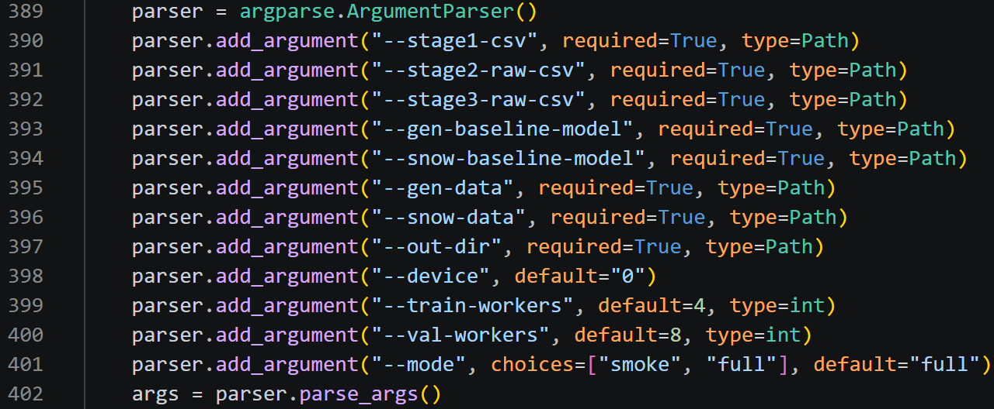
Reads arguments, creates clean output folders, writes input checksums, and records the exact training/evaluation settings.
- L460-L483 - Runs two SNOW tasks in smoke mode or all four C007/L9 by GEN/SNOW tasks in full mode.
- L485-L537
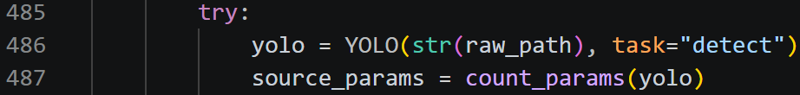
Loads each raw candidate, verifies the exact adapter-layer set, writes an architecture audit, and trains the supplied architecture.
- L542-L578 - In smoke mode, checks last.pt, parameters, architecture hash, and adapter layers after one epoch.
- L579-L631 - In full mode, validates best.pt, verifies the structure again, and writes baseline/raw/recovered mAP, retention, signed drop, and recovery gain.

S16 - Build and recover the p56 whole-layer-replacement model
Script: 09_layer_replacement_p56/run_gen50_efficiency_greedy.py
Role: Ranks single layers by parameter-saving efficiency, greedily selects whole layers, builds a raw model, recovers it, evaluates it, and bundles evidence.
Main inputs: Project root, GEN baseline, GEN dataset, output folder, optional single-layer CSV, target percentage, epochs, image size, batch, workers, seed, and device.
Main outputs: Layer ranking, selected layer list, raw unfused model, recovered best/last models, training results, metrics/report tables, summary, README, adapter copy, and bundle ZIP.
- L185-L274 - Finds the earlier single-layer result CSV and loads valid parameterized non-Detect candidates with their GEN accuracy drops.
- L277-L324
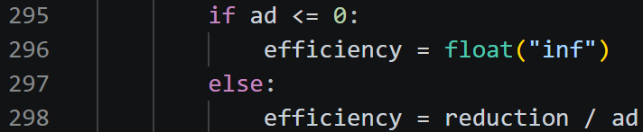
Calculates efficiency as individual parameter-reduction percentage divided by the previous GEN mAP50-95 drop, then ranks highest efficiency first.
- L327-L353
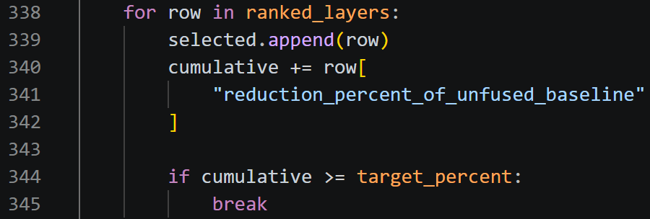
Adds layers greedily in ranking order until cumulative expected parameter reduction reaches or exceeds the target.
- L356-L569
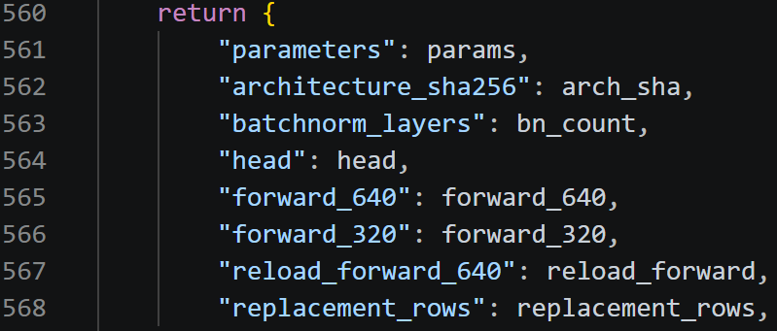
Captures each selected interface, loads a fresh unfused baseline, replaces all selected layers with adapters, checks forward passes at multiple sizes, saves/reloads the raw model, and verifies parameters/architecture/training capability.
- L572-L658
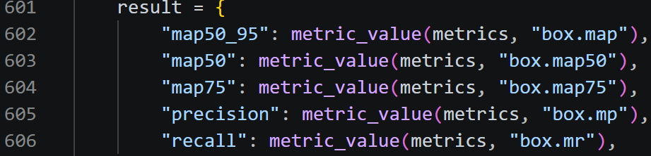
Defines throwaway validation and training-results checks so validation cannot fuse or damage the raw training source model.
- L661-L690 - Defines the exact-structure trainer used for recovery.
- L693-L909
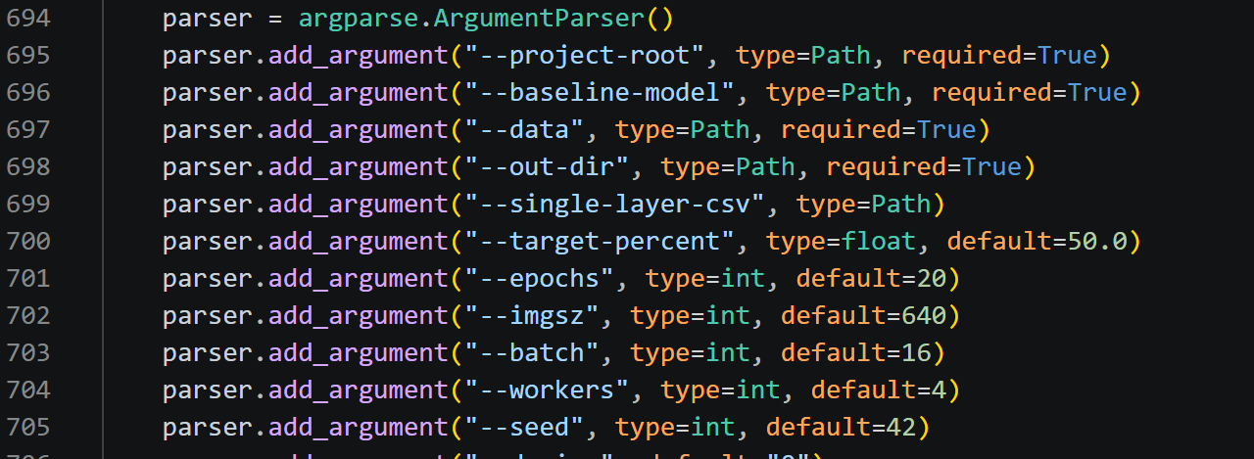
Reads arguments; the default target is 50%; loads/ranks candidates; selects layers; builds the raw model; and reports actual reduction.
- L986-L1178
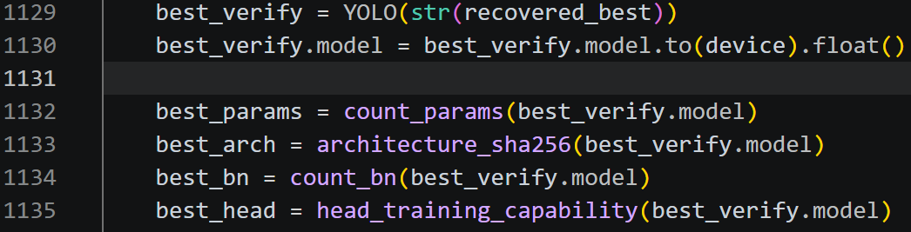
Validates baseline/raw on throwaway instances, performs 20-epoch exact-architecture recovery, verifies best/last/results, and runs final recovered validation.

5. mAP50-95 measurement
mAP is measured at several stages. The scripts below provide the baseline and NCNN measurement entry points; the pruning/replacement scripts above also run their own fixed raw or recovered validation.

S17 - Validate the supplied GEN and SNOW baseline checkpoints
Script: 11_mAP50_95_measurement/02_validate_supplied_baselines.py
Role: Profiles and re-validates both supplied full baselines under a fixed FP32 validation protocol.
Main inputs: GEN/SNOW checkpoints, GEN/SNOW dataset YAML files, output folder, device, workers, and expected frozen values embedded in the script.
Main outputs: Baseline validation CSV, checkpoint profile/hash evidence, environment data, and pass/fail summary.
- L17-L20 - Defines expected classes, parameter counts, and reference mAP values for GEN and SNOW.
- L38-L54
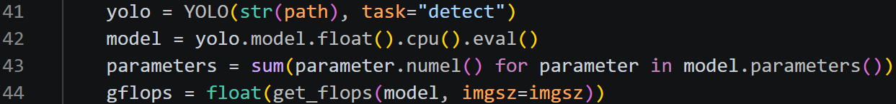
Profiles checkpoint class names, parameters, GFLOPs, file size, and SHA-256 hash.
- L57-L64 - Checks class and parameter counts before validation.
- L66-L88
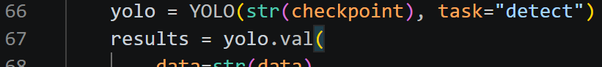
Runs fixed validation with 640 input, batch 16, rect=True, conf=0.001, IoU=0.70, max_det=300, FP32, no augmentation, and class-aware NMS.
- L90-L117
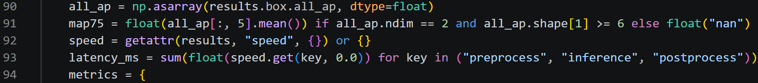
Extracts mAP50-95, mAP50, mAP75, precision, recall, and speed, then checks whether the result is within the built-in tolerance.
- L120-L151
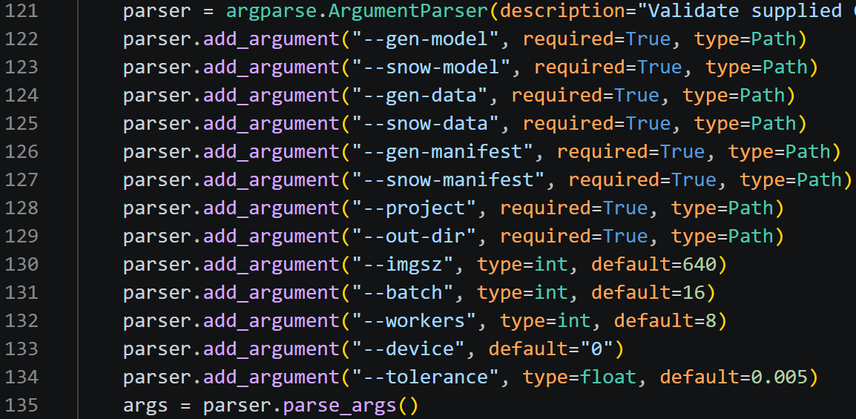
Reads arguments, checks files, sets repeatability controls, and validates GEN and SNOW.

S18 - Evaluate every compatible NCNN model on the server
Script: 12_NCNN_accuracy/evaluate_all_ncnn.py
Role: Discovers NCNN model folders, runs Ultralytics NCNN validation, and records overall and per-class accuracy for all compatible models.
Main inputs: Model-root directory, GEN/SNOW dataset YAML files, output directory, workers, and optional discovery/evaluation controls.
Main outputs: Overall result CSV, mAP-ranked CSV, per-class CSV, success/failure/skip evidence, summary JSON, README, and result ZIP.
- L53-L76 - Defines the exact GEN and SNOW class-name lists used to recognise model domains.
- L87-L166 - Normalizes metadata names, reads metadata.yaml, identifies GEN/SNOW/unsupported class spaces, and obtains the model input size.
- L216-L257
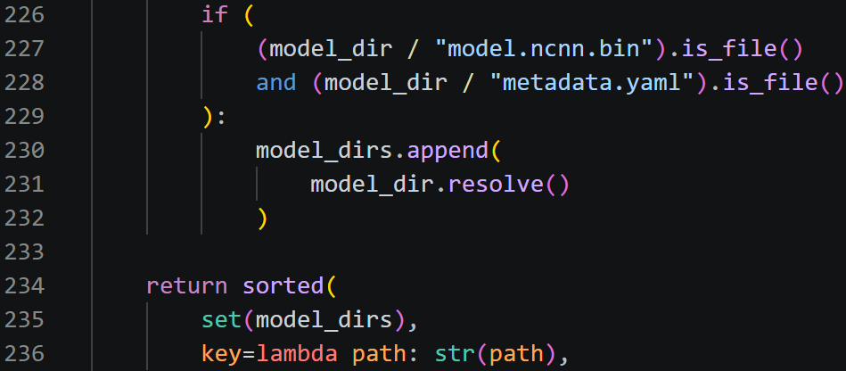
Recursively discovers folders containing model.ncnn.param, model.ncnn.bin, and metadata.yaml, then classifies FP32/FP16/INT8 variants.
- L260-L271 - Creates a temporary name ending in _ncnn_model so Ultralytics recognises the model directory as NCNN.
- L274-L344
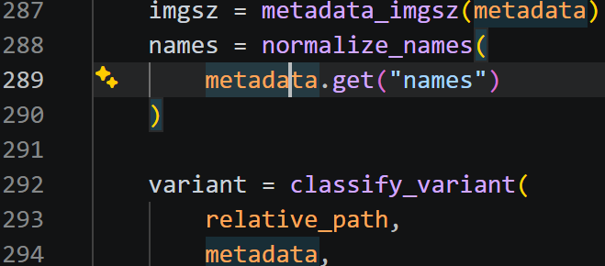
Loads one NCNN model, verifies metadata, and runs fixed batch-1 CPU validation using the model’s recorded input size.
- L346-L475
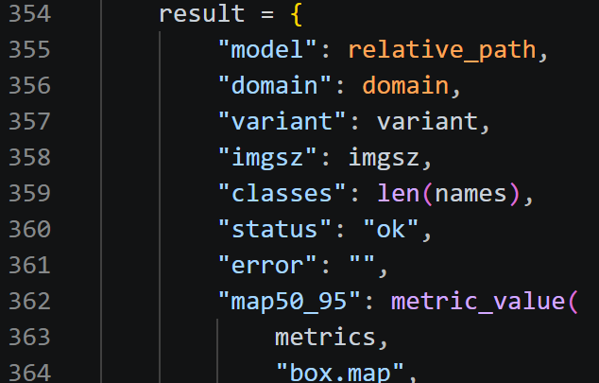
Collects overall mAP/precision/recall/speed/size/hashes and creates one row for every class.
- L505-L643 – (parser) Reads arguments, discovers models, determines each domain, and skips incompatible class spaces such as the official COCO model.
- L645-L710
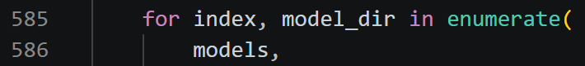
Evaluates each compatible model and continues to the next model after an individual failure.
- L712-L805 - ranks successful models by mAP50-95.

S19 - Launch the NCNN accuracy sweep in Apptainer
Script: 12_NCNN_accuracy/run_ncnn_accuracy.sh
Role: Provides the server environment, launches evaluate_all_ncnn.py inside the selected Apptainer image, captures the log, and packages passing results.
Main inputs: Environment-overridable model/data/project paths, Apptainer image, Python package paths, and worker count.
Main outputs: Timestamped output directory, full_run.log, evaluator results, latest symlink, and a ZIP containing results plus the log.
- L13-L30 - Defines overridable paths for models, GEN/SNOW YAML files, result parent, Apptainer image, Python packages, and worker count.
- L32-L43
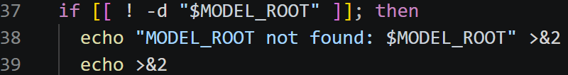
Tmestamped stops if MODEL_ROOT is missing.
- L45-L52 - Prints the effective paths and loads the Apptainer module.
- L54-L73
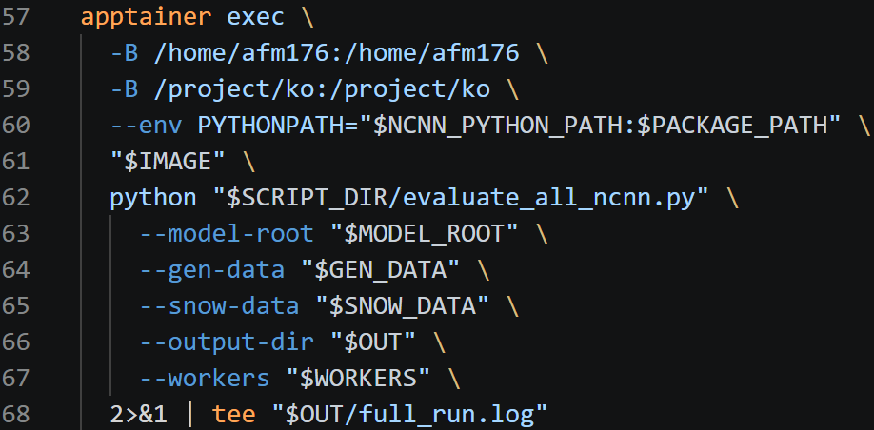
Temporarily disables fail-fast/pipefail around the container pipeline, runs evaluate_all_ncnn.py with bind mounts and PYTHONPATH, tees all output to full_run.log, and captures the Apptainer exit code.
- L75-L80 - Checks that the summary file.
- L82-L103 - Creates a ZIP that includes the CSV/JSON/README outputs and log.
- L106-L111 - Reports failure.

Part B - PC and PYNQ-Z2
1. PT to NCNN: default and INT8
These scripts convert PyTorch checkpoints to the three-file NCNN deployment format expected by the PYNQ runners.

P1 - Export a default FP32 NCNN model
Script: export_baseline_ncnn.py
Role: Uses Ultralytics to export one hard-coded .pt checkpoint to an FP32 NCNN model.
Main inputs: The model path edited at the top of the script and an importable layer_replacement_adapter module.
Main outputs: An Ultralytics NCNN model directory containing model.ncnn.param, model.ncnn.bin, and metadata.yaml.
- L6-L12
Defines a Windows checkpoint path and stops if the file is missing.
- L14
Loads the checkpoint with Ultralytics YOLO.
- L16-L25
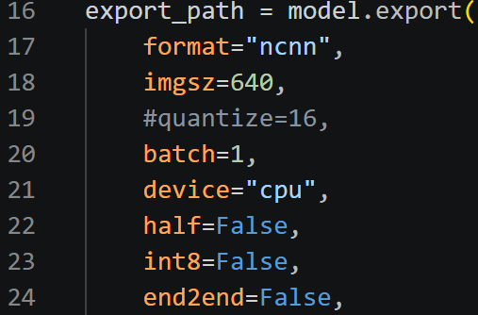
Exports NCNN at 640 pixels, batch 1, CPU, FP32, and end2end=False (can edit).

P2 - Export a .pt model and apply NCNN post-training INT8 quantization
Script: export_pt_to_int8_ncnn.py
Role: Exports FP32 NCNN, prepares representative images with deployment-matched preprocessing, creates an INT8 calibration table, and converts the graph/weights to INT8.
Main inputs: FP32 .pt model, calibration-image folder, NCNN tools folder containing ncnn2table/ncnn2int8, image size, thread count, maximum calibration images, and output folder.
Main outputs: INT8 model.ncnn.param/bin, metadata.yaml, model.int8.table, and printed FP32-versus-INT8 bin sizes.
- L16-L28 - Defines editable defaults for model, calibration images, NCNN tools, maximum images, input size, threads, and output directory.
- L41-L88 - Provides C++-compatible positive rounding, strict file/tool checks, command execution, and deterministic sorted calibration-image collection.
- L91-L154
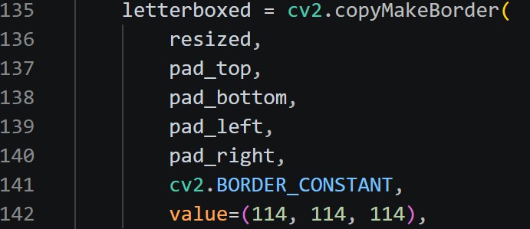
Reproduces the PYNQ letterbox geometry: aspect-preserving resize, centred 114 padding, and lossless PNG output.
- L157-L206 – (parser) Exposes the editable defaults as command-line arguments so individual values can be overridden.
- L208-L236
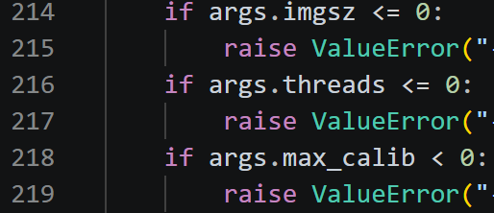
Validates inputs and refuses to mix a new model into a non-empty output folder.
- L238-L275
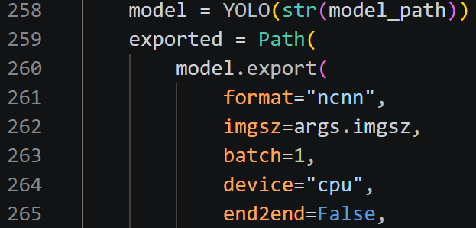
Collects representative images and exports the source .pt model to FP32 NCNN with batch 1, CPU, and end2end=False.
- L277-L312
Creates a temporary workspace and preprocesses every selected calibration image using the deployment-matched geometry.
- L314-L336
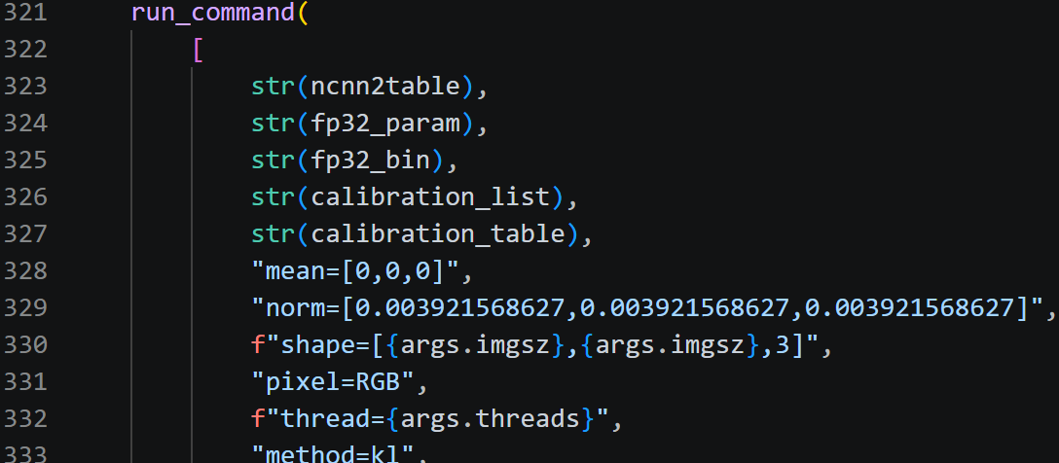
Calls ncnn2table using RGB conversion, 1/255 normalization, the requested shape/threads, and KL calibration.
- L338-L361
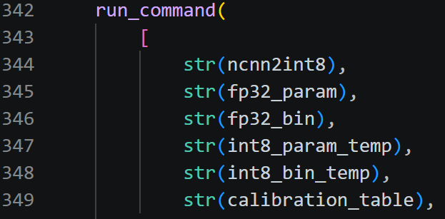
Calls ncnn2int8 and copies the INT8 files to the exact filenames expected by the existing PYNQ runner.

2. NCNN size and speed measurement
Two shell scripts standardise the board experiment. measure_model.sh is the outer evidence wrapper; run_model.sh supplies fixed validation and benchmark settings.

P3 - Outer wrapper for measuring one PYNQ model
Script: measure_model.sh
Role: Checks one NCNN deployment folder, records hashes/metadata, calls the shared experiment script, and prints key benchmark results.
Main inputs: Model folder name, mode (benchmark/validate/all), and optional image limit.
Main outputs: model_hashes.txt, copied metadata.yaml, files produced by run_model.sh, and a terminal summary of performance.csv.
- L15-L22
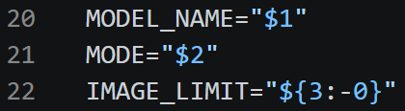
Validates the argument count and reads the model name, mode, and optional image limit.
- L24-L49 - Builds fixed PYNQ paths, restricts model-name characters, validates mode, and checks that the limit is a non-negative integer.
- L51-L71
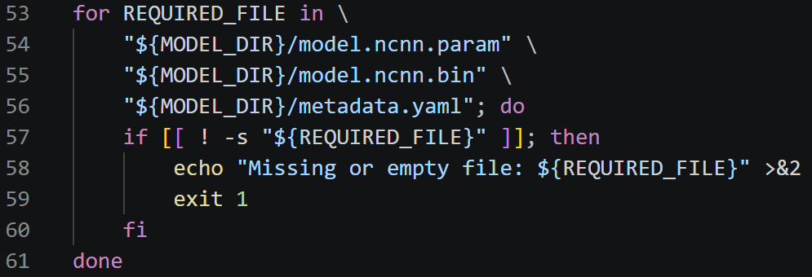
Requires non-empty param/bin/metadata files, the compiled C++ runner, and run_model.sh.
- L73-L84
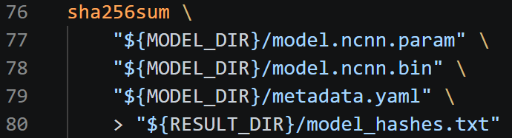
Creates the result folder, records SHA-256 hashes, and copies metadata beside the results.
- L108-L140 - When performance.csv exists, uses Python’s standard csv module to print median/P95 compute latency, FPS, peak RSS, and normalized CPU.

P4 - Apply fixed validation and benchmark settings on PYNQ
Script: run_model.sh
Role: Calculates deployed NCNN size and invokes the compiled runner in validate, benchmark, or both modes.
Main inputs: Model name, mode, optional image limit, optional IMGSZ environment variable, fixed board paths, validation list, and benchmark list.
Main outputs: model_size.csv, run_config.txt, predictions.csv/images.csv in validation mode, performance.csv in benchmark mode, and terminal file listing.
- L13-L28
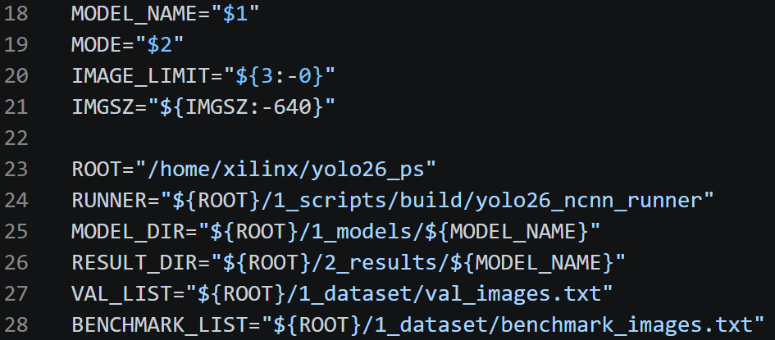
Reads arguments, accepts an IMGSZ environment override, and defines the board runner/model/result/image-list paths.
- L30-L57 - Checks mode, runner executable, required NCNN files, and image-limit format.
- L59-L76
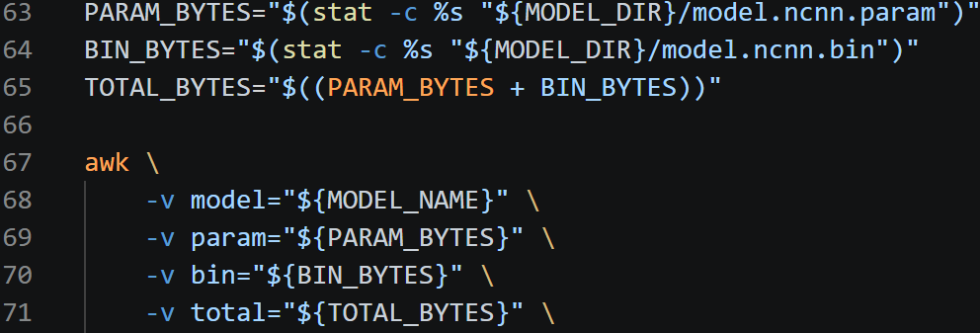
Calculates deployment size as model.ncnn.param bytes plus model.ncnn.bin bytes and writes model_size.csv.
- L78-L89 - Records board/run identity, input size, and the fixed two-thread setting.
- L91-L94 - Adds --limit only for a positive smoke-test limit.
- L96-L114
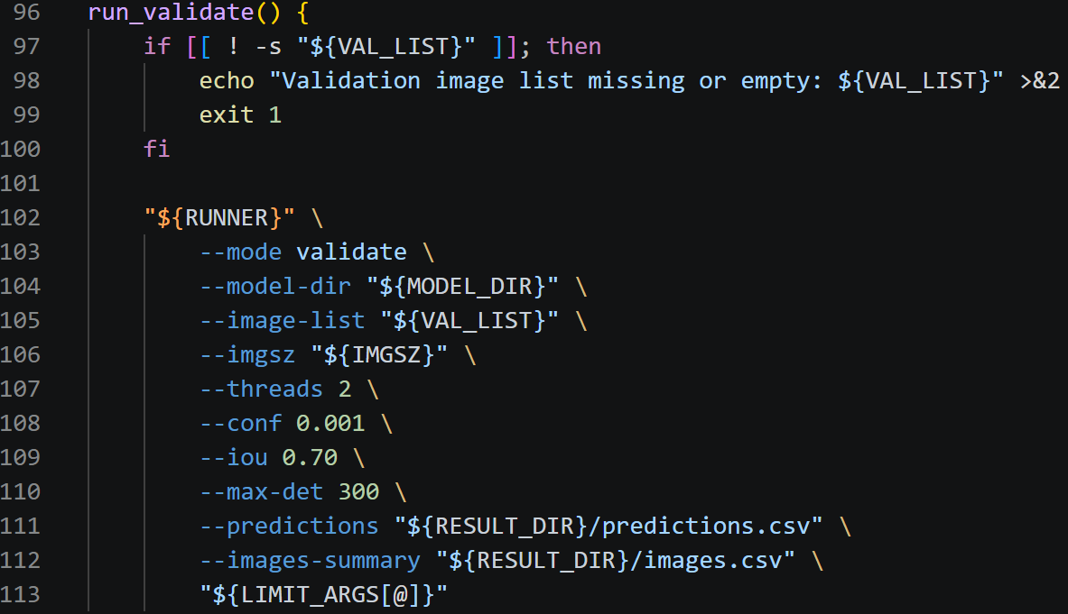
Validation mode calls the C++ runner with conf=0.001, IoU=0.70, max_det=300, and writes raw prediction/image CSV files.
- L116-L141
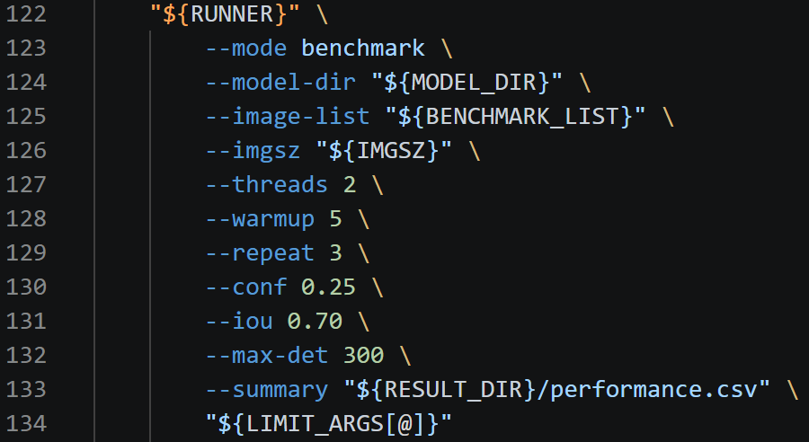
Benchmark mode uses five warm-ups, three repeats, conf=0.25, IoU=0.70, max_det=300, and writes performance.csv.

3. NCNN measurement runner
The C++ runner performs the actual CPU NCNN preprocessing, inference, decoding, validation-output generation, and performance measurement.

P5 - Offline NCNN validation and benchmark runner
Script: yolo26_ncnn_runner.cpp
Role: Loads one NCNN model and image list, performs YOLO detection on the PYNQ CPU, and either writes raw validation predictions or benchmark statistics.
Main inputs: Compiled command-line options, model.ncnn.param/bin, metadata.yaml, image-list text file, thresholds, image size, thread count, and mode-specific CSV paths.
Main outputs: Validation predictions/images CSV or one performance CSV containing latency, FPS, CPU, and memory measurements.
- L197-L310 – (parse) Parses all command-line options and requires the correct output paths for validate or benchmark mode.
- L313-L353
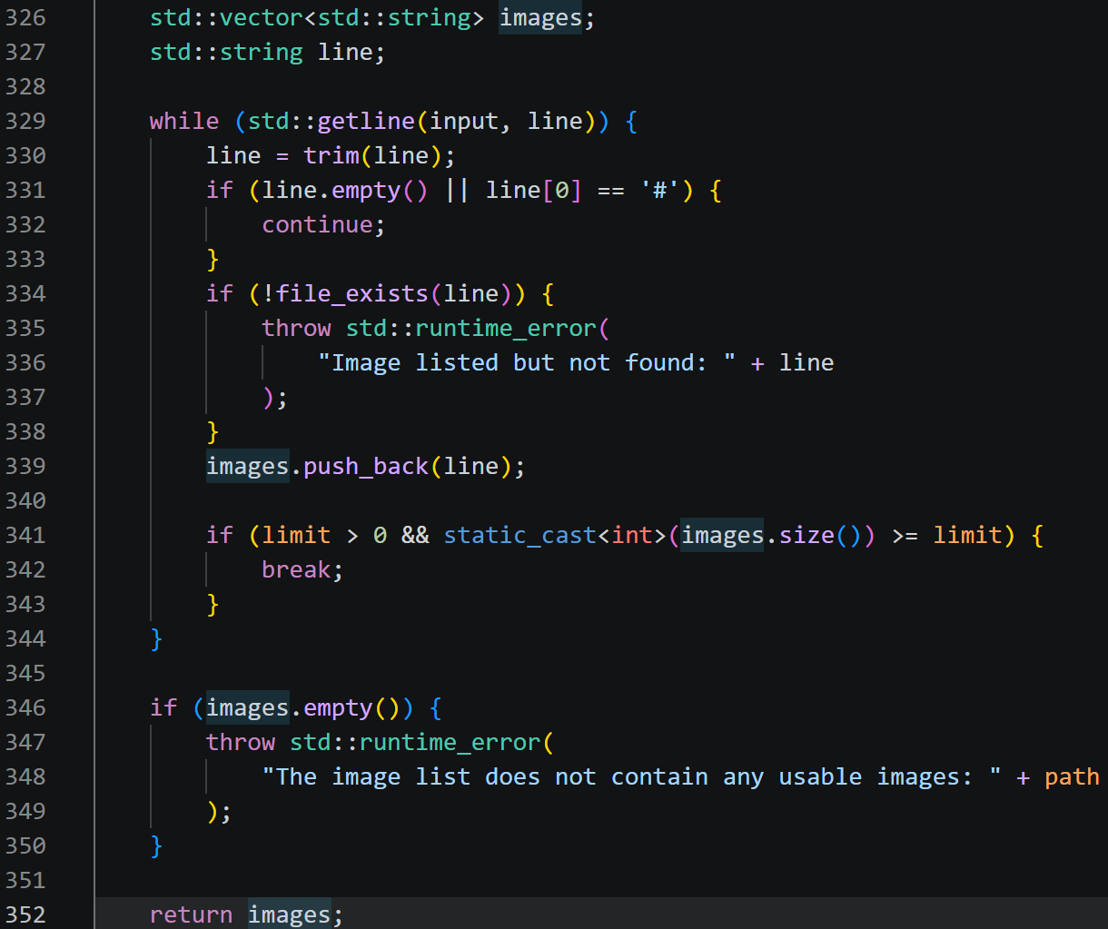
Reads the image list, ignores blank/comment lines, verifies every image, and applies an optional limit.
- L367-L450
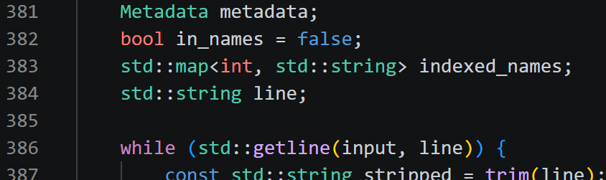
Reads the class-name mapping from metadata.yaml and requires a complete contiguous class ID list.
- L452-L549 - Reads BGR images, resizes with preserved aspect ratio, applies centred 114 letterbox padding, converts BGR to RGB, and normalizes by 1/255.
- L551-L611 - Accepts either features-by-anchors or anchors-by-features 2D NCNN output layout.
- L613-L715 - Computes IoU and applies class-aware non-maximum suppression.
- L717-L824 - Decodes the end2end=False YOLO output, selects the best class per anchor, maps boxes back through letterbox scaling, clips them, and applies NMS.
- L835-L915 - Runs one image through NCNN input blob in0 and output blob out0 while timing image read, preprocessing, inference, and postprocessing.
- L969-L1074 - Validate mode processes each image and writes one detection row plus one image-summary row.
- L1076-L1285 - Benchmark mode excludes warm-up runs, repeats inference, calculates mean/median/P95 latency, compute/total FPS, process CPU use, normalized board CPU, and peak RSS.
- L1289-L1359 - Loads metadata/images and the CPU-only NCNN network, sets the requested thread count, and dispatches the selected mode.

4. PC video to PYNQ, and PYNQ results back to PC
The live path is synchronous: the PC sends one JPEG frame, the board processes it, returns detections and timing, and only then does the PC send the next frame.

P6 - PC-side live video client
Script: stream_video.py
Role: Reads a PC video, sends selected JPEG frames to PYNQ, receives detections/timing, rescales boxes, and displays the annotated video.
Main inputs: PYNQ IP/port, video path, JPEG quality, send size, display width, maximum frames, frame-skip count, and a running PYNQ server.
Main outputs: An annotated live preview and per-frame terminal timing/status output.
- L14-L23
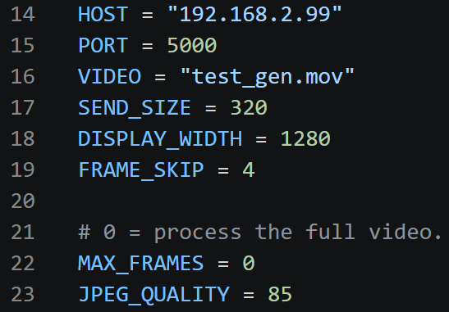
Defines editable defaults for host, port, video, send size, display size, frame skip, maximum frames, and JPEG quality (can edit).
- L41-L53 - Defines a fixed 11-class GEN label list for drawing returned class IDs (if you need SNOW, then extra class list is needed, but SNOW video can still be tested, box is fine but class may wrong).
- L56-L119
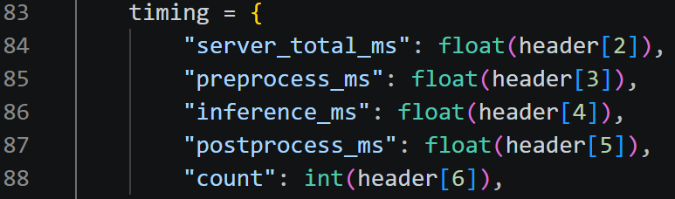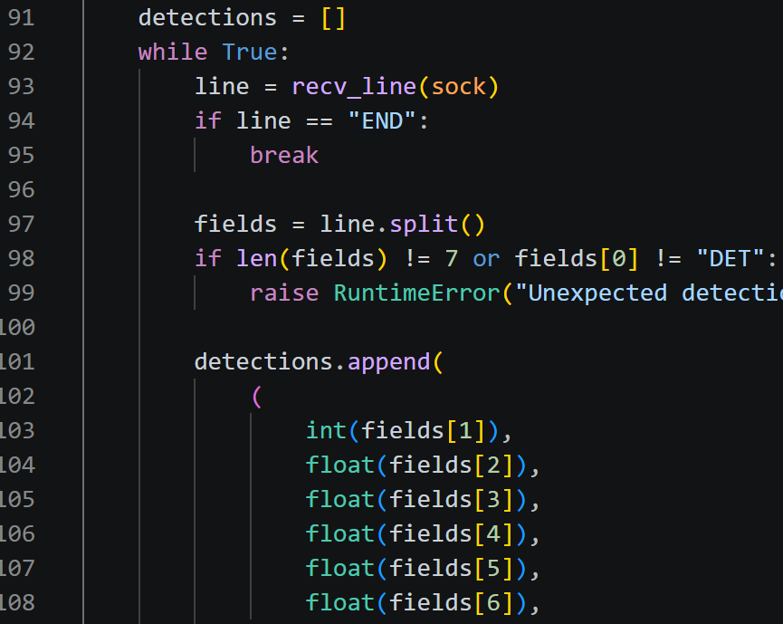
Reads line-oriented TCP responses, verifies the frame ID and reported detection count, and parses RESULT/DET/END records.
- L122-L188 – (parser) Exposes every editable default as a command-line override.
- L190-L230 - Prints and validates the effective settings, opens the video, connects to PYNQ, and removes the per-frame socket timeout after connection.
- L239-L264 - Reads a source frame and downsizes it on the PC while preserving aspect ratio to reduce JPEG/network/board work.
- L266-L282
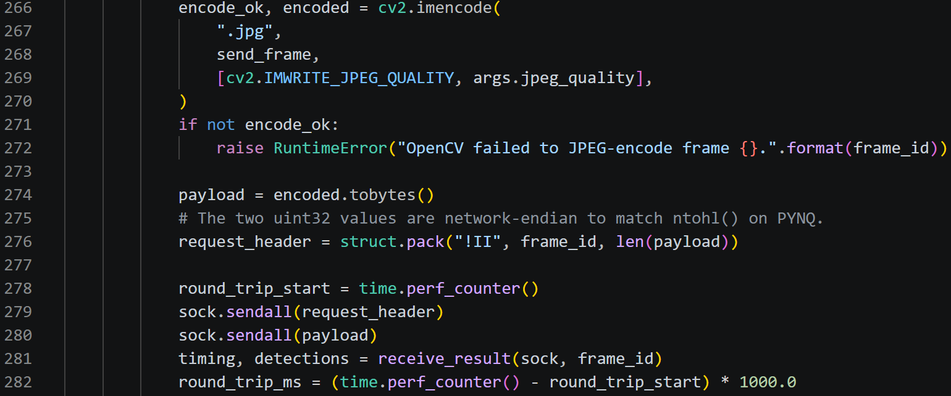
JPEG-encodes the frame, sends network-endian frame ID and payload length followed by bytes, then waits synchronously for the matching result.
- L284-L309
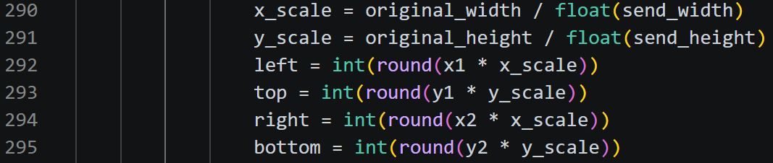
Scales detection coordinates from the sent frame back to the original video resolution and draws boxes/labels.
- L311-L350
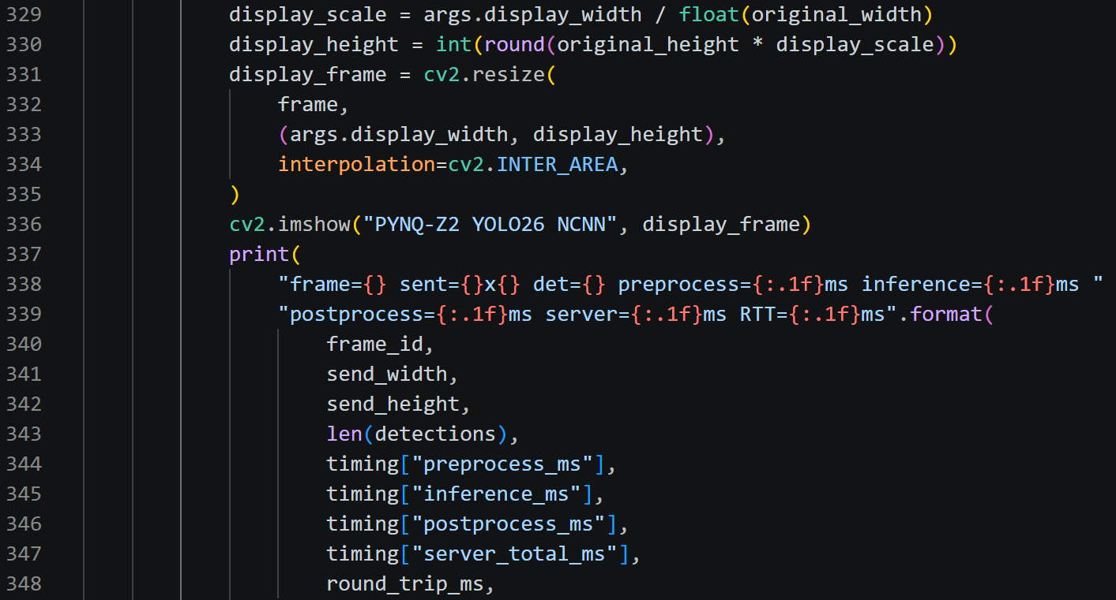
Displays detection count, inference time, round-trip time, and a resized preview window.
- L352-L365
Stops on Q and skips source frames with capture.grab() so skipped frames are not decoded or sent.
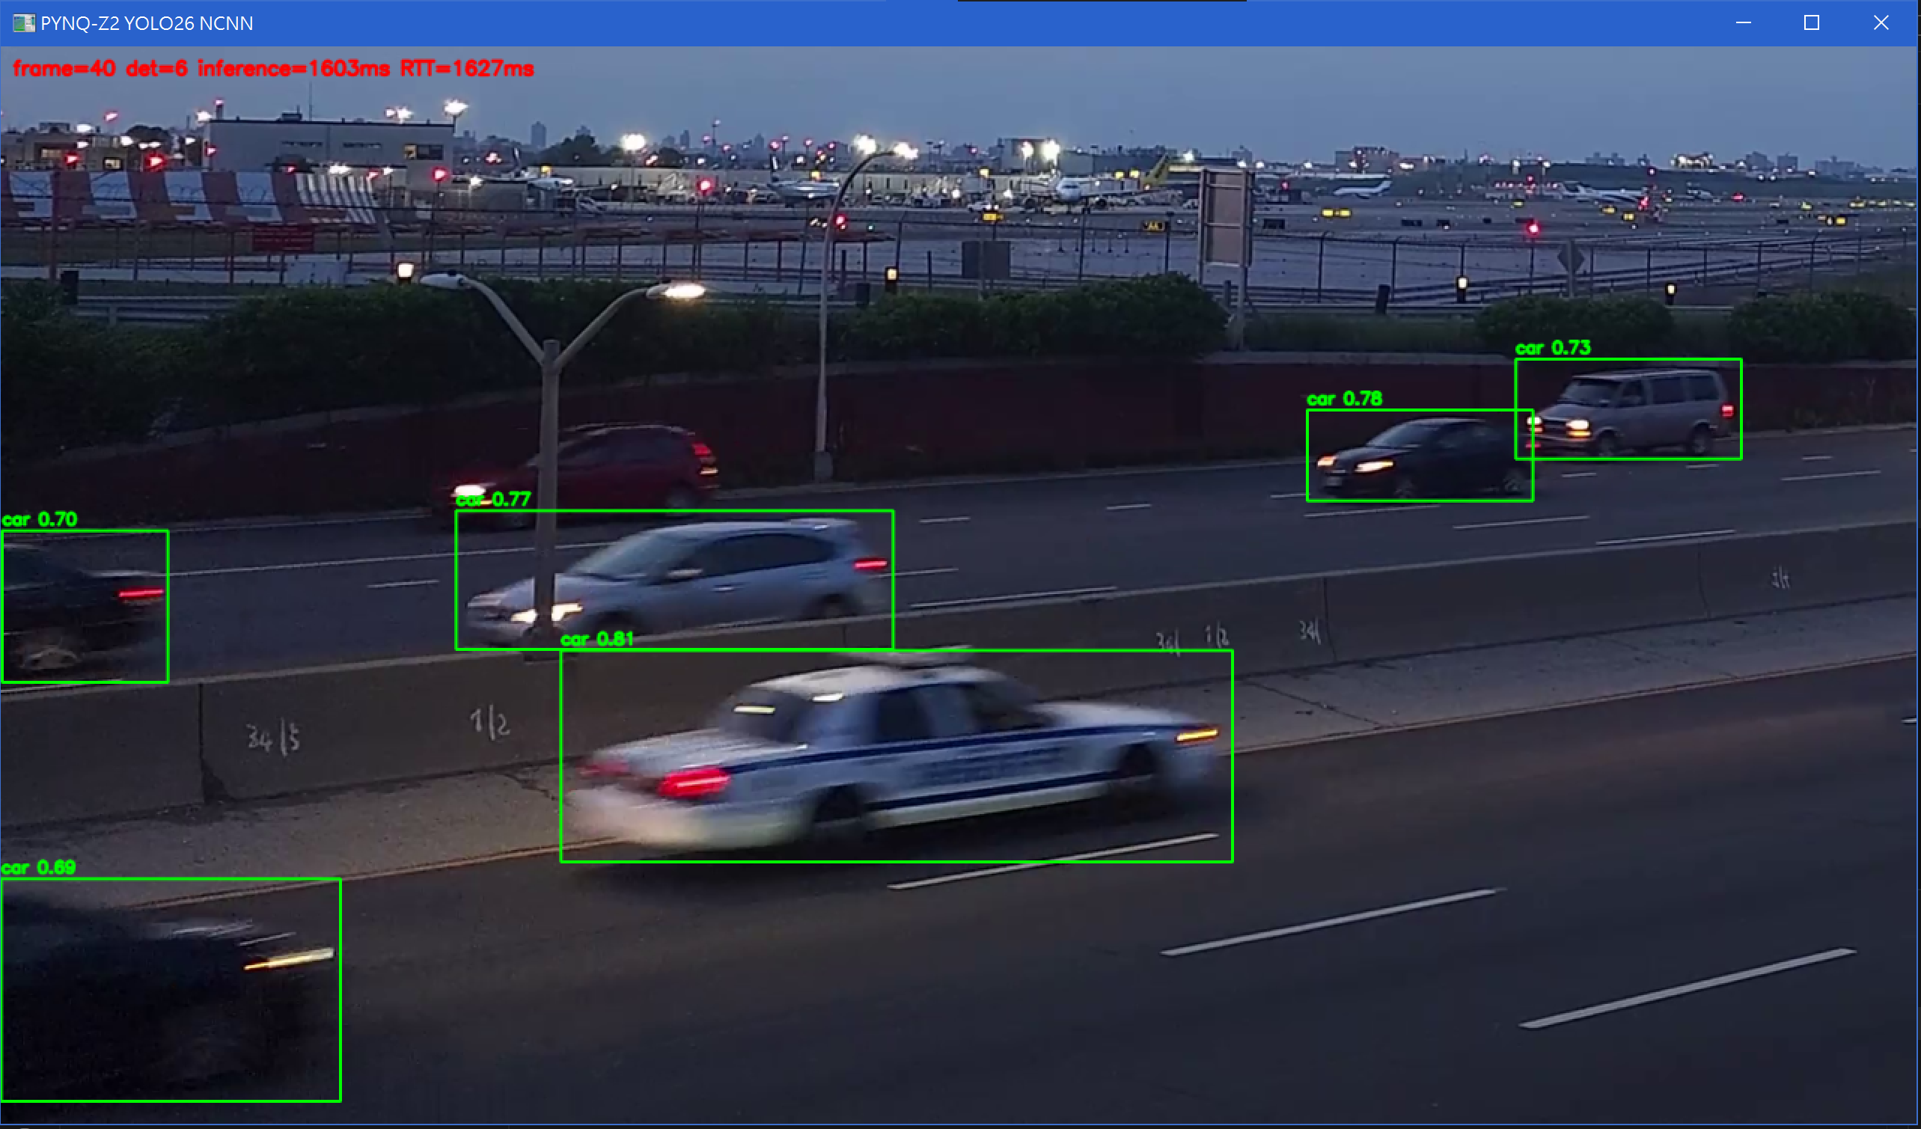

P7 - PYNQ-side live NCNN TCP server
Script: yolo26_ncnn_server.cpp
Role: Loads the NCNN model once, accepts one PC connection, receives JPEG frames, runs CPU inference/NMS, and returns detections plus timing.
Main inputs: Compiled command-line settings, model directory, image size, thread count, port, confidence/IoU thresholds, maximum detections, and incoming TCP frames.
Main outputs: Line-oriented RESULT/DET/END responses and server-side per-frame logs.
- L101-L164 - Reads class names from metadata.yaml.
- L166-L245 - Performs the same aspect-preserving 114-letterbox, BGR-to-RGB conversion, and 1/255 normalization as the offline runner.
- L247-L290 - Determines the 2D NCNN output orientation.
- L292-L371 - Computes IoU and class-aware NMS.
- L373-L442 - Decodes end2end=False YOLO output and maps boxes back to the received JPEG frame.
- L444-L505 - Runs preprocessing, NCNN in0-to-out0 inference, decoding, and records three timing components.
- L507-L538 - Implements exact-length receive/send loops because one TCP call is not guaranteed to transfer a complete record.
- L542-L617 - Parses/validates command-line settings, requires param/bin/metadata, and loads one CPU NCNN network for reuse across all frames.
- L619-L676 - Creates the TCP socket, enables address reuse, binds/listens, and accepts one client.
- L678-L716 - Receives [uint32 frame_id][uint32 jpeg_size][JPEG bytes], rejects invalid/over-20-MiB payloads, decodes JPEG, and runs inference.
- L717-L738 - Returns RESULT with server/preprocess/inference/postprocess times, one DET line per box, and an END marker.
- L740-L756 - Logs each frame and closes the client/server sockets on completion or error.

mAP50-95 in
Model | Script | Measurement | Lines
Full .pt baselines | 02_validate_supplied_baselines.py | GEN and SNOW. | L66-L117
Global-L1 raw | stage5c_exact_core.py | saved raw pruned checkpoint. | L690-L795
Global-L1 recovered p10 | 08_full_20epoch_recovery.py | after recovery. | L571-L603
Global-L1 recovered p56 | stage5e_exact_core.py via run_exact_gen56_pipeline.py | recovered p56 | L571-L741; L160-L219
Layer replacement p10 | 05_recover_and_evaluate_selected.py | Compare baseline, raw, and recovered C007/L9. | L579-L631
Layer replacement p56 | run_gen50_efficiency_greedy.py | baseline/raw/recovered models. | L986-L1368
NCNN on server | evaluate_all_ncnn.py | Ultralytics NCNN validation. | L274-L475
NCNN on PYNQ C++ | yolo26_ncnn_runner.cpp | raw detections (50 for full, can change). | L969-L1074

